**HYBRID METAHEURISTIC APPROACH FOR NON-LINE-OF-SIGHT VEHICLE LOCALIZATION TO ENHANCE EMERGENCY MESSAGE PROPAGATION IN VEHICULAR AD-HOC NETWORKS**

**A PROJECT REPORT**

**(Phase II)**

***Submitted by***

|  |  |
| --- | --- |
| **SRI RAJADURAI S** | **Register No: 21UEC181** |
| **PRANAV R** | **Register No: 21UEC134** |
| **KADALI PRASANTH KUMAR** | **Register No: 21ECL006** |

*Under the Guidance of*

**Dr. SB. LENIN**

**Associate Professor, Department of ECE**

***in partial fulfilment for the award of the degree of***

**BACHELOR OF TECHNOLOGY**

***in***

**ELECTRONICS AND COMMUNICATION ENGINEERING**



**SRI MANAKULA VINAYAGAR ENGINEERING COLLEGE**

**(An Autonomous Institution)**

**MADAGADIPET, PUDUCHERRY-605107**

**PONDICHERRY UNIVERSITY: PUDUCHERRY-605014**

**APRIL 2025**



**SRI MANAKULA VINAYAGAR ENGINEERING COLLEGE**

## (An Autonomous Institution)

**MADAGADIPET, PUDUCHERRY – 605 107**

**BONAFIDE CERTIFICATE**

This is to certify that the project work entitled **HYBRID METAHEURISTIC APPROACH FOR NON-LINE-OF-SIGHT VEHICLE LOCALIZATION TO ENHANCE EMERGENCY MESSAGE PROPAGATION IN VEHICULAR AD-HOC NETWORKS** is a Bonafide work done by **SRI RAJADURAI S [REGISTER NO: 21UEC181], PRANAV R [REGISTER NO: 21EC134], KADALI PRASANTH KUMAR [REGISTER NO: 21ECL006]** in partial fulfillment of the requirement for the award of Bachelor of Technology degree in the Department of Electronics and Communication Engineering during the academic year 2024.

Signature

**Dr. P. Raja**

Head of the Department

Signature

**Dr. SB. Lenin**

Associate Professor

Submitted for End Semester Examination held on

**INTERNAL EXAMINER EXTERNAL EXAMINER**

## ACKNOWLEDGEMENT

First, we would like to thank our guide, **Dr. SB. Lenin**, *Assistant* *Professor, Department of Electronics and Communication Engineering,* for the valuable guidance and advice. He inspired us greatly to work on this project. His ability to inspire us has made an enormous contribution to our project.

We would like to thank our project coordinator, **Dr. SB. Lenin**, *Associate Professor, Department of Electronics and Communication Engineering*, for the valuable guidance and endless support.

We would like to take this opportunity to express our gratitude to **Dr. P. Raja**, *Professor and Head of the Department, Electronics and Communication Engineering*, for giving us valuable suggestions. He has always been a source of inspiration and encouragement towards the project.

We would like to take this opportunity to thank our respected Director cum Principal, **Dr. V.S.K. Venkatachalapathy** and our Management for providing us the best ambience to complete this project.

We would like to thank all the Electronics and Communication Engineering Department Teaching Staff and Technical Staff for their support in completing this project.

Finally, for the motivation and assistance in completing this mission, an honorable mention goes to our families and friends. Without their support, we would have faced many challenges while doing this project.

# ABSTRACT

Non-Line-of-Sight (NLOS) vehicle localization presents a significant hurdle in Vehicular Ad Hoc Networks (VANETs), impacting how nodes are positioned and how emergency messages are shared. Traditional methods often falter when faced with dynamic obstacles, high mobility, and signal interference, which can lead to delays and lower packet delivery rates. This research introduces a hybrid metaheuristic approach that combines Ant Colony Optimization (ACO) and Simulated Annealing (SA) to boost the accuracy of NLOS localization. ACO is great at exploring the best node positions, but it can sometimes settle for less-than-ideal solutions too quickly. On the other hand, SA enhances these solutions through probabilistic tweaks, which helps in achieving better global optimization. This combined method not only improves localization accuracy but also cuts down on message delays and enhances packet delivery rates, ensuring dependable communication in urban VANETs. Extensive simulations demonstrate that the ACO-SA approach surpasses standalone ACO, SA, and traditional methods in terms of accuracy, scalability, and efficiency. By fine-tuning node placement and message routing, this system paves the way for smarter transportation and emergency response, pushing forward the development of next-generation VANET applications in smart cities.

***Keywords:*** *NLOS Localization, VANETs, Metaheuristic Algorithms, Ant Colony Optimization, Simulated Annealing, Emergency Message Propagation, Urban Environments*

*i*

## TABLE OF CONTENTS

|  |  |  |  |  |  |
| --- | --- | --- | --- | --- | --- |
| **CHAPTERNO.** | **TITLE** | | | | **PAGENO.** |
|  | *Abstract*  *List of Figures*  *List of Tables*  *List of Abbreviations* | | | | *i*  *ii*  *iv*  *v* |
| **1** | **INTRODUCTION** | | | | **1** |
|  | 1.1 | INTRODUCTION TO VANETs AND URBAN NLOS CONDITIONS | | | 1 |
|  |  | | Overview of the Vehicular Ad Hoc Networks (VANETs) | | 1 |
|  |  | | Characteristics of Urban Environments | | 1 |
|  |  | | Challenges in Non-Line-of-Sight  (NLOS) conditions | | 1 |
|  |  | | Relevance of NLOS Localization in VANET Applications | | 1 |
|  | 1.2 | RESEARCH MOTIVATION AND PROBLEM OVERVIEW | | | 2 |
|  | 1.2.1 | | Motivation for accurate Localization in VANET | | 3 |
|  | 1.2.2 | | Problem Definition and Research Gaps | | 3 |
|  | 1.2.3 | | Need for Improved Solutions in Urban NLOS Scenarios | | 4 |
|  | 1.3 | AIMS AND OBJECTIVES OF THE RESEARCH | | | 4 |
|  | 1.3.1 | | Main Research Aim | | 4 |
|  | 1.3.2 | | Specific Research Objectives | | 5 |
|  | 1.3.3 | | Expected Outcomes of the Research | | 5 |
|  | 1.4 | THE IMPORTANCE OF LOCALIZATION IN NLOS ENVIRONMENTS | | | 6 |
|  |  | | Critical Role of Localization in VANET | | 6 |
|  | 1.4.2 | | Implications of Poor Localization in Safety-Critical Systems | | 7 |
|  | 1.4.3 | | NLOS Conditions: Technical Challenges | | 7 |
|  | 1.4.4 | | How Localization Enhances Communication and reliability | | 8 |
|  | 1.4.5 | | Application Areas Benefiting from Improved Localization | | 8 |
|  | 1.5 | RESEARCH DESIGN OVERVIEW | | | 10 |
|  | 1.5.1 | | Simulation and Algorithmic Models | | 10 |
|  | 1.5.2 | | Data Collection and Evaluation Methods | | 11 |
|  | 1.5.3 | | Tools and Technologies Used | | 11 |
| **2** | **LITERATURE SURVEY** | | | | **12** |
|  | 2.1 | OVERVIEW | | | 12 |
|  | 2.2 | LITERATURE SURVEY | | | 12 |
|  | 2.3 | COMPARISON OF EXISTING SYSTEMS | | | 25 |
|  | 2.4 | EXISTING WORK | | | 30 |
|  | 2.5 | CONCLUSION | | | 30 |
| **3** | **METHODOLOGY** | | | | **31** |
|  | 3.1 | INTRODUCTION | | | 31 |
|  | 3.2 | PROBLEM STATEMENT | | | 31 |
|  | 3.3 | PROPOSED ALGORITHM | | | 31 |
|  | 3.3.1 | | Ant Colony Optimization | | 31 |
|  | 3.3.1.1 Flowchart of ACO | | | | 32 |
|  | 3.3.1.2 Pseudo Code of ACO | | | | 33 |
|  | 3.3.1.3 Key Components of ACO | | | | 34 |
|  | 3.3.1.4 Benefits of ACO in VANET | | | | 35 |
|  | 3.3.2 | | Simulated Annealing (SA) | | 35 |
|  | 3.3.2.1 Flowchart of SA | | | | 36 |
|  | 3.3.2.2 Pseudo Code of SA | | | | 37 |
|  | 3.3.2.3 Key Components of SA | | | | 38 |
|  | 3.3.2.4 Benefits of SA in VANET | | | | 39 |
|  | 3.4 | CHALLENGES OF UTILIZING SIMULATED ANNEALINGANDANT COLONY OPTIMIZATION IN ISOLATION | | | 40 |
|  | 3.4.1 | | Convergence Issues | | 40 |
|  | 3.4.2 | | Parameter Sensitivity | | 41 |
|  | 3.4.3 | | Lack of Global Search Capability Simulated Annealing (SA) | | 41 |
|  | 3.4.4 | | Computational Complexity Simulaed Annealing (SA) | | 41 |
|  | 3.5 | HYBRID TECHNOLOGY: SIMULATED ANNEALING (SA) AND ANT COLONY OPTIMIZATION (ACO) | | | 42 |
|  | 3.5.1 | | Flowchart of the Hybrid Technology | | 42 |
|  | 3.5.2 | | Pseudo Code of the hybrid Technology | | 44 |
|  | 3.5.3 | | Benefits of the Hybrid Technology | | 46 |
|  | 3.5.3.1 | | | *Improved Convergence Performance* | 46 |
|  | 3.5.3.2 | | | *Balanced Exploration and Exploitation* | 46 |
|  | 3.5.3.3 | | | Reduced Stagnation and Local optima | 46 |
|  | 3.6 | IMPROVEMENTS IN FIELD OF VANET | | | 46 |
|  | 3.7 | EXPECTED OUTCOMES | | | 47 |
| **4** | **RESULT** | | | | **48** |
|  | 4.1 | OVERVIEW | | | 48 |
|  | 4.2 | IMPACT OF NODE DENSITY ON LOCALIZATION ACCURACY | | | 50 |
|  | 4.3 | EFFECT OF LOCALIZATION ERRORS ON EMERGENCY MESSAGE DELIVERY RATE | | | 51 |
|  | 4.4 | LATENCY IN EMERGENCY MESSAGE PROPAGATION VS. NODE DENSITY | | | 53 |
|  | 4.5 | PACKET LOSS RATE ACROSS DIFFERENT LOCALIZATION TECHNIQUES | | | 54 |
|  | 4.6 | IMPACT OF LOCALIZATION ACCURACY ON NETWORK THROUGHPUT IN VANETS | | | 56 |
|  | 4.7 | INFLUENCE OF ANCHOR NODE DENSITY ON LOCALIZATION ACCURACY IN VANETS | | | 58 |
|  | 4.8 | COMPARATIVE ANALYSIS OF METAHEURISTIC ALGORITHMS IN VEHICLE LOCALIZATION | | | 58 |
|  | 4.9 | SCALABILITY ANALYSIS OF HYBRID LOCALIZATION METHODS IN DENSE VANETS | | | 61 |
|  | 4.10 | OPTIMIZED NODE LOCALIZATION AND ROUTING IN VANETS USING HYBRID ACO-SA ALGORITHM | | | 62 |
| **5** | **FUTURE WORK** | | | | **65** |
| **6** | **REFERENCES** | | | | **66** |

**LIST OF FIGURES**

|  |  |  |
| --- | --- | --- |
| **FIGURENO.** | **TITLE** | **PAGENO.** |
| 1.1 | A typical urban VANET scenario. | 2 |
| 1.2 | Communication types in VANET | 3 |
| 1.3 | NLOS Conditions signals | 4 |
| 1.4 | Localization in LOS/NLOS environments. | 6 |
| 1.5 | Positioning system | 7 |
| 1.6 | Types of Localization Challenge | 8 |
| 1.7 | 1. NLOS positioning scenario 2. LiDAR scanning scenario | 8 |
| 1.8 | Illustration of communication in VANETs enabled by accurate localization | 9 |
| 1.9 | Diagram showing how smart parking systems leverage accurate vehicle positioning. | 10 |
| 3.1 | Flowchart of ACO | 33 |
| 3.2 | Flowchart of SA | 37 |
| 3.3 | Flowchart of Hybrid Technology | 44 |
| 4.1 | Impact of Node Density on Localization Accuracy in NLOS VANETs | 54 |
| 4,2 | Effect of Localization Errors on Emergency Message Delivery Rate | 54 |
| 4.3 | Analysis of Latency in Emergency Message Propagation with Varying Node Density | 53 |
| 4.4 | Evaluation of Packet Loss Rate Across Different Localization Techniques | 55 |
| 4.5 | Influence of Localization Accuracy on Network Throughput in VANETs | 57 |
| 4.6 | Effect of Anchor Node Density on Localization Error in Vehicular Networks | 59 |
| 4.7 | Comparative Performance Analysis of Metaheuristic Algorithms for Vehicle Localization | 60 |
| 4.8 | Scalability Assessment of Hybrid Localization Methods in Dense VANETs | 62 |
| 4.9 | Optimized Routing Path Using Hybrid ACO-SA Approach | 63 |

**LIST OF TABLES**

|  |  |  |
| --- | --- | --- |
| **TABLE NO.** | **TITLE** | **PAGENO.** |
| 2.1 | Comparison of Existing Systems | 25 |

*iv*

**CHAPTER 1**

**INTRODUCTION**

**1.1 INTRODUCTION TO VANETS AND URBAN NLOS CONDITIONS**

Vehicular Ad Hoc Networks (VANETs) are a specialized type of mobile ad hoc network that enables communication between vehicles, playing a critical role in enhancing traffic safety, optimizing flow, and supporting intelligent transport systems [1]. Accurate localization is especially important in urban environments, where visibility is often limited due to dense infrastructure [2].

**1.1.1 Overview of Vehicular Ad Hoc Networks (VANETs)**

VANETs support both Vehicle-to-Vehicle (V2V) and Vehicle-to-Infrastructure (V2I) communication [3], enabling applications like hazard alerts, traffic updates, and navigation support [4]. Their structure typically includes three domains: mobile (vehicles), infrastructure (roadside units), and a generic control system [5]. Fast and reliable information exchange helps prevent accidents and manage congestion, particularly in high-density urban settings [6][7][8].

**1.1.2 Characteristics of Urban Environments**

Urban areas with tall buildings, narrow streets, and vegetation often cause Non-Line-of-Sight (NLOS) conditions that impair VANET performance [9][10]. These obstacles degrade signal quality and GPS accuracy, especially in environments with high vehicle density and dynamic traffic flows [11][12][13][14].

**1.1.3 Challenges in Non-Line-of-Sight (NLOS) Conditions**

NLOS affects vehicle positioning by introducing signal reflections, diffraction, and interference [15][16][17]. Multipath effects from building reflections and intermittent blockage by moving objects like vehicles or pedestrians further degrade localization accuracy [18][19][20].

**1.1.4 Relevance of NLOS Localization in VANET Applications**

Reliable localization is essential for safety-critical VANET applications such as collision avoidance and emergency response [8][10][12]. Inaccurate positioning can delay warning messages or cause misrouting. Smart cities and sectors like agriculture and healthcare also benefit from precise localization, which enhances traffic control, field automation, and emergency navigation in urban zones [14][15][16][17][18].

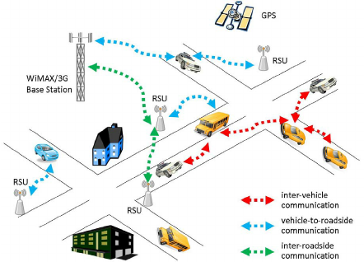

Figure 1.1: A typical urban VANET scenario.

**1.2 RESEARCH MOTIVATION AND PROBLEM OVERVIEW**

The rapid advancement of technology has resulted in notable improvements in vehicular communication systems, especially within the framework of Vehicular Ad Hoc Networks (VANETs) [1]. These networks aim to enable communication among vehicles as well as between vehicles and roadside infrastructure [2]. With urban areas becoming more congested, the importance of precise localization in VANETs has reached a critical point [3]. This section delves into the reasons for enhancing localization accuracy in VANETs, outlines the related challenges, pinpoints research gaps, and examines how Non-Line-of-Sight (NLOS) conditions affect network performance [4]. Accurate localization plays a pivotal role in ensuring the timely delivery of safety messages and effective routing decisions. However, obstacles such as buildings, tunnels, and dense traffic often obstruct signals, leading to degraded communication quality. Therefore, robust localization strategies capable of overcoming NLOS conditions are essential for improving the reliability and efficiency of VANET-based systems.

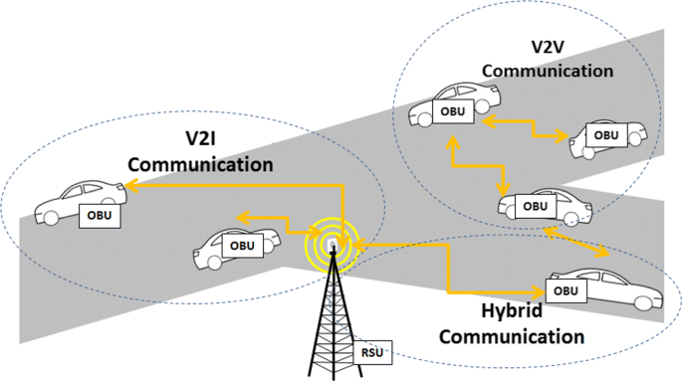

Figure 1.2: Communication types in VANET

**1.2.1. Motivation for Accurate Localization in VANETs**

VANETs are central to Intelligent Transportation Systems (ITS), supporting applications like traffic management, accident prevention, and navigation [5][6]. In urban environments, GPS performance often deteriorates due to signal blockage from buildings and tunnels [7]. To overcome this, alternative techniques like Received Signal Strength (RSS)-based localization are employed to improve accuracy through Roadside Units (RSUs) [8].

**1.2.2. Problem Definition and Research Gaps**

Despite progress in localization methods, urban settings present persistent challenges due to dynamic vehicle movement and frequent signal obstructions [9]. A major issue is the **NLOS problem**, where physical barriers lead to inaccurate position estimates [10][21]. Many existing models fail to adapt to changing urban conditions or traffic patterns [11][12], leading to reduced accuracy and system reliability [13].

Inaccurate localization impacts not only individual vehicle navigation but also network performance [14], increasing latency and error rates in communication protocols [15]. This degrades Quality of Service (QoS), delays emergency responses, and weakens traffic control systems [16][17]. The consequences of NLOS signal distortion are illustrated in **Figure 1.3**, which shows how buildings and obstacles interfere with signal propagation.

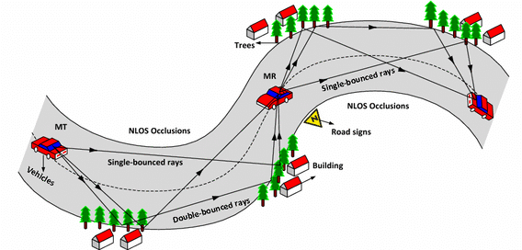

Figure1.3**:** NLOS Conditions signals.

**1.2.3. Need for Improved Solutions in Urban NLOS Scenarios**

To address these issues, improved localization techniques tailored to urban NLOS environments are essential [18][22]. Machine learning approaches can analyze past patterns and environmental data to predict and mitigate NLOS effects [19]. Furthermore, integrating fog computing with VANETs enables localized data processing, enhancing real-time responsiveness and reducing dependence on remote cloud services [20]. Such approaches can significantly improve vehicle awareness and decision-making in critical urban scenarios.

**1.3 AIMS AND OBJECTIVES OF THE RESEARCH**

The growing complexity of urban environments and the rapid advancement of vehicular technologies demand a focused investigation into the localization challenges faced by Vehicular Ad Hoc Networks (VANETs) [1]. This section presents the primary aim, specific objectives, and expected outcomes of this research [2], aiming to enhance localization accuracy under urban Non-Line-of-Sight (NLOS) conditions—benefiting domains such as environmental monitoring, smart agriculture, healthcare, industrial automation, and smart cities [3].

**1.3.1 Main Research Aim**

The growing complexity of urban settings, along with the swift progress in vehicle technologies, calls for a detailed investigation into the localization issues encountered by Vehicular Ad Hoc Networks (VANETs) [4**]**. This section highlights the main goals and objectives of this research, presents specific research questions, and outlines the expected results [5]. By tackling these aspects, we seek to provide valuable solutions to improve localization accuracy in urban non-line-of-sight (NLOS) conditions, which could benefit various sectors such as environmental monitoring, smart agriculture, healthcare, industrial automation, and smart cities [6].

**1.3.2 Specific Research Objectives**

To achieve the main aim outlined above, several specific research objectives have been established:

* To analyze existing localization techniques: Review current methods used in VANETs, with a focus on those addressing NLOS challenges [7][23].
* To develop a hybrid localization algorithm: Combine traditional positioning methods with machine learning to improve localization accuracy in complex urban settings [8].
* To evaluate algorithm performance: Conduct simulations in urban NLOS scenarios to assess the effectiveness of the proposed method [9].
* To assess real-world application impact: Study how improved localization benefits smart city applications such as traffic control and emergency services [10].
* To propose future research directions: Recommend enhancements and identify gaps for further exploration in vehicle localization [11].

**1.3.3 Expected Outcomes of the Research**

The expected results of this research are diverse and aim to make a significant impact on both academic knowledge and real-world applications [13]:

* Development of a hybrid localization algorithm: An innovative algorithm that merges machine learning and traditional techniques to overcome NLOS issues [14].
* Comprehensive performance evaluation: Detailed assessment comparing the new algorithm with existing methods in varied urban environments [15].
* Implementation guidelines: Actionable strategies for integrating the proposed solution into real VANET systems [16].
* Impact across application domains: Enhanced practices in areas like healthcare logistics, environmental monitoring, smart agriculture, and industrial automation [17].
* New research directions: Insights into unresolved challenges and future development opportunities in vehicle localization [18].

**1.4 THE IMPORTANCE OF LOCALIZATION IN NLOS ENVIRONMENTS**

Localization is a critical component in numerous modern applications, especially under Non-Line-of-Sight (NLOS) conditions where signal obstructions are prevalent. Accurate localization enhances communication, reliability, and safety across domains like Vehicular Ad-hoc Networks (VANETs), smart cities, healthcare, and industrial automation.

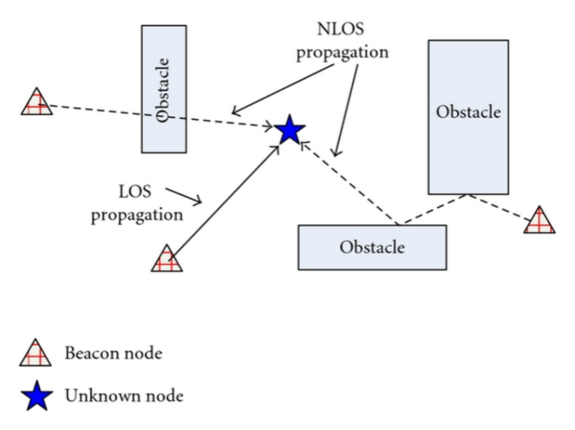

Figure 1.4: localization in LOS/NLOS environments.

**1.4.1 Critical Role of Localization in VANETs**

In VANETs, precise positioning is essential for enabling communication between vehicles and infrastructure. This facilitates:

* Collision avoidance
* Traffic management
* Navigation

Traditional localization methods struggle in NLOS settings due to signal obstructions caused by buildings or other vehicles. Techniques like **Time of Arrival (TOA)**, combined with filtering algorithms that account for NLOS errors, improve accuracy in such environments.

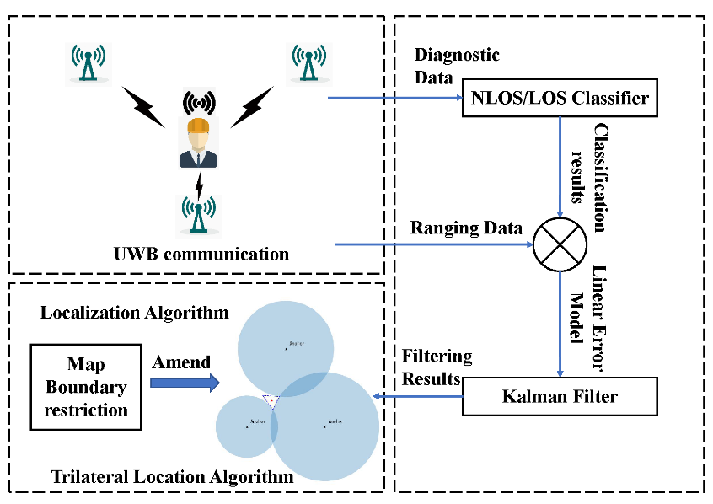

Figure 1.5: positioning system

**1.4.2 Implications of Poor Localization in Safety-Critical Systems**

Localization inaccuracies can be detrimental in safety-critical scenarios such as:

* **Driving is autonomous,** leading to miscommunication and collisions
* **Emergency healthcare systems** – affecting timely response and monitoring
* **Industrial safety systems** – risking equipment and worker safety

A lack of dependable localization undermines the reliability and safety of these systems.

* + 1. **NLOS Conditions: Technical Challenges**

Key NLOS-related challenges include:

* **Signal Reflection and Diffraction**: Signals bounce off buildings or bend around obstacles, causing delays and distortions that make the localization process more challenging [16].
* **Increased Latency**: NLOS conditions frequently lead to higher latency in message delivery, as vehicles might have to retransmit signals multiple times [17].
* **Interference**: High-density urban areas raise the chances of interference from various sources, which can further diminish signal quality [18].

**1.4.4 How Localization Enhances Communication and Reliability**

Effective localization significantly improves communication reliability across a range of applications by allowing devices to accurately assess their positions in relation to each other and their surroundings [19].

* **Smart Agriculture:** Accurate vehicle positioning allows agricultural machinery to function effectively within fields while steering clear of obstacles [20].
* **Environmental Monitoring:** Vehicles fitted with sensors can precisely map environmental data points, leading to improved resource management [3].

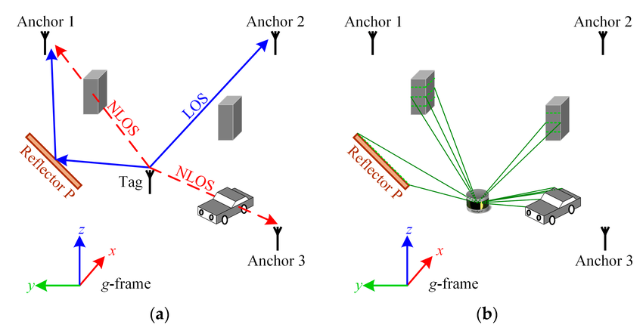

Figure 1.7: (a) NLOS positioning scenario; and (b) LiDAR scanning scenario.

**1.4.5. Application Areas Benefiting from Improved Localization**: Showcasing how different sectors leverage accurate vehicle positioning.

**1. Enhanced Navigation in VANETs**

In the context of VANETs, precise localization is vital for enabling vehicles to communicate effectively with each other and with roadside infrastructure [8][25]. This capability is essential for various applications, including:

* **Collision Avoidance Systems:** Vehicles with precise localization can exchange real-time information about their locations and movements, which allows for timely alerts and evasive maneuvers to avert accidents [9].
* **Traffic Management:** Accurate positioning data supports efficient routing algorithms that enhance traffic flow. By knowing the exact locations of vehicles and potential obstacles, traffic management systems can dynamically adjust traffic signals and provide real-time navigation updates to drivers (HERE Technologies, 2023) [10].

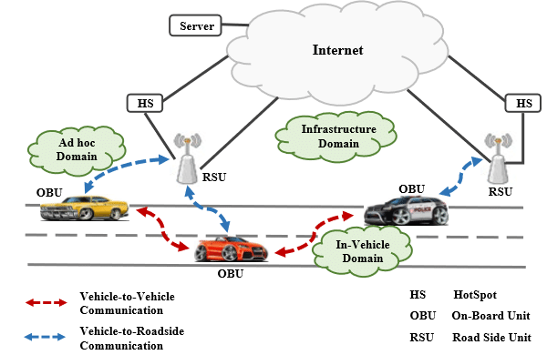

Figure 1.8: Illustration of communication in VANETs enabled by accurate localization.

**2. Smart Parking Solutions**

Smart parking systems make use of real-time data from vehicles and parking sensors to effectively direct users to available spaces [11]. With precise localization, these systems can:

* **Optimize Parking Space Utilization:** By accurately identifying the locations of vehicles and parking spots, smart parking solutions can decrease the time drivers spend looking for available spaces, which helps to reduce congestion [12].
* **Enhance User Experience:** Users get real-time updates on parking availability via mobile apps, simplifying navigation in urban areas [13].

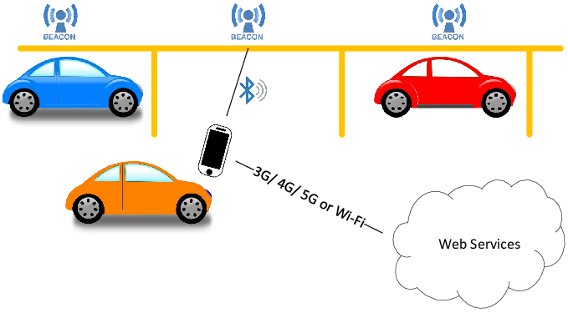

Figure 1.9: Diagram showing how smart parking systems leverage accurate vehicle positioning.

**1.5 RESEARCH DESIGN OVERVIEW**

This study adopts a mixed-methods approach to exploring VANETs in smart parking and urban environments, integrating qualitative and quantitative data for a comprehensive understanding.

* **Qualitative Methods:** Interviews and focus groups with city planners, transport officials, and tech providers capture insights on user expectations and experiences with smart city initiatives [19].
* **Quantitative Methods:** Surveys and simulations are used to analyze trends in traffic flow, parking availability, and vehicle communication [14].

By integrating these methods, the study provides a thorough analysis of how VANETs can improve urban mobility and operational efficiency.

**1.5.1 Simulation and Algorithmic Models**

**Simulation modeling** plays a key role in understanding VANET dynamics. Virtual environments are created to test algorithms for traffic and parking management [8][26].

• **Traffic Simulation Models:** These models replicate vehicle interactions within a network. Techniques like Cellular Automata (CA) and Agent-Based Modeling (ABM) are used to analyze traffic flow dynamics under varying conditions. For example, CA can illustrate how vehicles react to changes in road conditions or traffic signals [15].

• **Algorithmic Models:** Algorithms such as LEACH (Low-Energy Adaptive Clustering Hierarchy) introduced by Heinzelman et al. (2000) and PEGASIS (Power-Efficient Gathering in Sensor Information System) by Lindsey & Raghavendra (2002) are modified for vehicular networks to improve energy efficiency and the reliability of data transmission [10]. These simulation models allow for the testing of various strategies for reducing congestion and improving parking efficiency in urban settings.

**1.5.2 Data Collection and Evaluation Methods**

Data collection validates simulation results and reveals user behavior in smart cities [17].

* **Surveys:** Gather user feedback on satisfaction, usage frequency, and perceived benefits of smart parking systems [30].
* **Sensor Data:** Collected from traffic cameras, GPS, and parking sensors to monitor traffic patterns and occupancy rates [20].
* **Historical Data Analysis:** Past traffic studies serve as a reference for evaluating current systems using statistical tools to find meaningful patterns [14]

**1.5.3 Tools and Technologies Used**

This research project employs a variety of tools and technologies:

* **Simulation Software:** Programs like MATLAB or AnyLogic are used to create simulation models that mimic real-world scenarios in urban settings [4].
* **Data Analysis Tools:** Software such as R or Python is used for statistical analysis, enabling advanced analytics like predictive modeling[15].
* **Visualization Tools:** Tableau and GIS software to display traffic and parking trends over time [7].

**CHAPTER 2**

**LITERATURE SURVEY**

**2.1 OVERVIEW**

The literature survey reveals progress in VANETs, focusing on NLOS localization, data dissemination, and dynamic topology handling. Optimization methods like ACO and SA, along with hybrid models such as SHSAOA and PSO-IMChan, enhance routing and scalability. Techniques like CACONET and DA-TRPED improve delivery in dense areas. However, scalability and computational demands remain issues. Emerging tools like blockchain and machine learning offer potential solutions. Hybrid, adaptive approaches are key to improving VANET performance in complex environments.

**2.2 LITERATURE SURVEY**

**[1] S. B. Lenin, N. Tamilarasan2, “Spotted Hyena Optimization and Simulated Annealing‑Based NLOS Nodes Localization Scheme for Improving Warning Message Dissemination in VANETs”, 2022**

S.B. Lenin and N. Tamilarasan (2022) emphasize the need for efficient NLOS node localization to enhance VANET accuracy. Traditional methods, like range-based and range-free schemes, face challenges such as high computational complexity and environmental sensitivity. To overcome these, the authors propose a novel SHSAOA algorithm, combining Spotted Hyena Optimization with Simulated Annealing to balance exploration and exploitation. Evaluated through metrics like warning message delivery rate, neighborhood awareness, channel utilization, and localization error, SHSAOA outperforms existing methods like ROALS, GWCSOALS, and ISTEOA. This approach shows promise for improving NLOS localization in VANETs.

**[2] Petr Stodola and Jan Nohel, “Adaptive Ant Colony Optimization with Node Clustering for the Multidepot Vehicle Routing Problem”, 2023**

To address the limitations of traditional ACO algorithms—like premature convergence and slow optimization in large-scale MDVRP problems—Stodola and Nohel (2023) propose the Adaptive Ant Colony Optimization with Node Clustering (AACO-NC) algorithm. Its core innovation is clustering transition nodes to focus on more promising solution areas. An adaptive pheromone evaporation mechanism is introduced, adjusting rates based on population diversity to maintain exploration–exploitation balance. A new termination condition halts the search when diversity drops below a threshold. Tested on 23 benchmarks, AACO-NC outperformed or matched state-of-the-art algorithms in 17 cases while reducing optimization time.

**[3] Zishi Wang and Yaohua Wu, “An Ant Colony Optimization-Simulated Annealing Algorithm for Solving a Multiload AGVs Workshop Scheduling Problem with Limited Buffer Capacity”, 2023**

Wang et al. (2023) highlight the need for effective NLOS identification and mitigation to enhance UWB indoor positioning accuracy. Existing approaches—like residual analysis, statistical feature methods, machine learning, and geometric-based techniques—face challenges such as high complexity and environmental sensitivity. To address this, the authors propose a machine learning-based NLOS mitigation method that improves positioning accuracy. They also explore geometric methods, including distance matrix constraints and non-closure detection, and emphasize the role of optimization techniques like linear quadratic programming. Overall, the study suggests machine learning and geometric methods hold strong potential for improving NLOS mitigation in UWB systems.

**[4] Lin Wu, Ahmad Yahya Dawod and Fang Miao, “Data Transmission in Wireless Sensor Networks Based on Ant Colony Optimization Technique”, 2024**

In Wireless Sensor Networks (WSNs), optimizing data transmission while conserving energy remains a key challenge due to limited node resources and scalability issues. Clustering and routing techniques like LEACH and its variants (EHE-LEACH, S-EECP, M-EECP) aim to extend network lifespan through probability-based cluster head (CH) selection, though they often suffer from limited local decision-making. To improve efficiency, evolutionary algorithms like PSO and SA have been applied to enhance CH selection and network stability. Protocols like MSRP and PEGASIS-based routing introduce mobile convergence points but depend on impractical location-awareness assumptions. Wang et al. (2024) proposed an ACOD-based routing technique, integrating K-means clustering and an improved Whale Optimization Algorithm (WOA) to balance energy consumption and improve coverage. Simulations showed reduced node death rates and energy usage, highlighting the effectiveness of this multi-algorithmic approach for WSN optimization.

**[5] Akhilesh Bijalwan, Iqram Hussain, Kamlesh Chandra Purohit, and M. Anand Kumar, “Enhanced Ant Colony Optimization for Vehicular Ad Hoc Networks Using Fittest Node Clustering”, 2023**

Hussain et al. (2023) proposed an Enhanced Ant Colony Optimization (EACO) framework using intelligent clustering to improve VANET routing. Traditional protocols struggle with rapid topology changes, leading to packet loss and delays. To address this, the authors introduced the DA-TRPED technique, which uses parallel Euclidean distance (PED) for efficient cluster head (CH) selection, enhancing packet delivery, throughput, and reducing delays. Naeem et al. (2023) also developed an improved clustering-based routing protocol aimed at extending CH and member lifespans, promoting energy efficiency and reduced communication overhead. Additionally, Khan et al. (2019) presented a hybrid fuzzy logic-guided genetic algorithm for resource optimization in 5G VANETs, highlighting the value of adaptive algorithms in vehicular communication.

**[6] Shanshan Chen, Zhicai Shi*, Fei Wu*, Changzhi Wang, Jin Liu, and Jiwei Chen,” Improved 3-D Indoor Positioning Based on Particle Swarm Optimization and the Chan Method”, 2018**

Wylie & Holtzman (1996) and others have proposed methods to mitigate NLOS errors, including weighted least squares (Luo & Shukla, 2006), maximum likelihood estimators (Riba & Urruela, 2004), and the residual weighting algorithm (Chen, 1999). However, these techniques often suffer from high computational complexity and limited accuracy in NLOS environments (Chang et al., 2017). To address this, Chen et al. (2018) introduced a 3D indoor positioning method using Particle Swarm Optimization (PSO) and an improved Chan algorithm (PSO-IMChan). This approach frames the problem as a global optimization task, where PSO provides an initial estimate, followed by fast iterative refinement using the improved Chan algorithm. Experimental results demonstrate higher positioning accuracy, lower complexity, and strong practicality compared to traditional methods.

**[7] Pavan Kumar Pagadala, Vivek Bhardwaj, P. Lalitha Surya Kumari, Mohammad Shahid, Deepak Thakur, Abdulrajak Buradi, Abdul Razak, and Abiot Ketema, “Slow Heat-Based Hybrid Simulated Annealing Algorithm in Vehicular Ad Hoc Network”, 2023**

The literature review identifies key challenges and solutions for VANET routing. Pagadala and Saravana Kumar (2021) addressed WiFi limitations—like capacity constraints and mobility—using a hybrid SA-GSO algorithm. Shaikh and Hingoliwala (2017) proposed an optimization scheme to adjust transmission parameters while maintaining QoS. Zhao et al. (2019) used a bees life algorithm for QoS-multicast routing, while Bitam and Mellouk (2013) introduced Cat Swarm Optimization for geographic routing. Other contributions include QoS-aware routing with ACO and BCO (Kasana & Kumar, 2017), an improved shuffled frog-leaping algorithm (Malathi & Sreenath, 2018), and a hybrid metaheuristic for OLSR optimization (Gautami et al., 2016). These studies tackle issues like topology changes, fragmentation, and resource use, highlighting a shift toward hybrid, nature-inspired algorithms to enhance VANET routing performance.

**[8] Santanu Majumdar, Shivashankar, Rajendra Prasad P, Santosh Kumar S, Sunil Kumar K N, “An Efficient Routing Algorithm based on Ant Colony Optimisation for VANETs”, 2016**

Vehicular Ad Hoc Networks (VANETs) have been widely studied, with various routing and communication solutions proposed. Tonguz et al. (2008) emphasized the benefits of broadcasting, while Debajit and Majumder (2013) introduced an Ant-based QoS-aware routing algorithm for MANETs. Wu et al. (2013) developed a direction and destination-based routing approach, and Oham and Radenkovic (2015) proposed a congestion-aware spray-and-wait protocol. Correia et al. (2011) and Chuka et al. (2014) focused on mobility-aware ACO and congestion control, respectively. Despite their contributions, issues like high latency, packet loss, and energy consumption remain. To address these, the current study proposes a bio-inspired Ant Colony Optimization (ACO) technique using artificial ants and neighbors to enhance route discovery and reduce delay. Simulated in MATLAB-2015b, the proposed method outperforms earlier algorithms in throughput, packet delivery ratio, and latency.

**[9] Farhan Aadil, Khalid Bashir Bajwa, Salabat Khan, Nadeem Majeed Chaudary, and Adeel Akram, “CACONET: Ant Colony Optimization (ACO) Based Clustering Algorithm for VANET”, 2018**

Rawashdeh & Mahmud (2012) noted that conventional clustering algorithms like K-means and hierarchical clustering are insufficient for VANET challenges (Basu et al., 2001; Gerla et al., 1995). Similarly, multi-objective evolutionary algorithms such as MOPSO and CLPSO face limitations in clustering optimization (Ali et al., 2012; Shahzad et al., 2009). To overcome these issues, Khan et al. (2016) proposed CACONET, an Ant Colony Optimization (ACO)-based approach that incorporates dynamic transmission ranges, mobility models, and pheromone update rules. Experimental results show that CACONET outperforms MOPSO and CLPSO by reducing the number of clusters and enhancing packet delivery ratio, offering improved connectivity and data delivery in heterogeneous VANETs.

**[10] A. Balamurugan, M. Deva Priya, A. Christy Jeba Malar, and Sengathir Janakiraman, “Raccoon optimization algorithm‑based accurate positioning scheme for reliable emergency data dissemination under NLOS situations in VANETs”, 2021**

The literature review highlights several challenges and solutions for NLOS node localization in VANETs. A. Balamurugan et al. (2021) proposed the Raccoon Optimization Algorithm-based Accurate Positioning Scheme (ROA-APS) to enhance localization accuracy. Earlier, Rohani et al. (2015) introduced a Bayesian approach using GPS data but faced low accuracy. Li et al. (2016) employed a two-state Markov chain for cooperative localization, improving position estimation but increasing communication overhead. Fascista et al. (2016) developed BPCLA for better angular resolution, though limited by multipath effects. Alodadi et al. (2017) proposed CVP-NPS, which improved channel utilization and awareness but had scope for reducing localization error. Amuthan and Kaviarasan (2019) introduced DVBAWI-NLS to improve latency and emergency message delivery. Collectively, these studies aim to enhance accuracy, reduce overhead, and ensure reliable data dissemination in NLOS conditions.

**[11] A. Amuthan and R. Kaviarasan, “Weighted inertia-based dynamic virtual bat algorithm to detect NLOS nodes for reliable data dissemination in VANETs”, 2018**

Vehicular Ad Hoc Networks (VANETs) face major challenges in localizing non-line-of-sight (NLOS) nodes due to obstacles that disrupt communication, increasing latency and accident risks. Traditional methods like signal strength-based approaches (Xiao et al., 2006) and trust-based models (Leinmüller et al., 2008) suffer from high energy use and computational overhead. Techniques like GRANT (Capkun et al., 2008) and echo-packet schemes (Sastry et al., 2003) improve security but add processing delays. Cooperative protocols like CVEBLM (Alodadi et al., 2017) enhance reliability but are time-consuming. Time-of-flight methods (Song et al., 2008) offer accuracy but lack efficiency. To overcome these limitations, Amuthan and Kaviarasan (2018) proposed the Weighted Inertia-Based Dynamic Virtual Bat Algorithm (WIDVBA), integrating Simulated Annealing and PSO to optimize NLOS localization. By dynamically adjusting search scope, WIDVBA improves global search efficiency and avoids premature convergence. Simulations in EstiNet 8.1 show WIDVBA enhances neighborhood awareness by 33%, reduces execution time by 30%, and boosts emergency message delivery by 35%, while also lowering latency by 12% and energy consumption by 15%. These results highlight WIDVBA’s potential in improving VANET communication and reliability under NLOS conditions.

**[12] Ramu Kaviarasan, Pillutla Harikrishna, “Localizing non-line-of-sight nodes in Vehicluar Adhoc Networks using gray wolf methodology”, 2020**

Vehicular Ad Hoc Networks (VANETs) face ongoing challenges in localizing non-line-of-sight (NLOS) nodes due to obstacles like buildings and large vehicles, which disrupt direct communication and delay emergency message delivery. Several methods have aimed to address this, including HiRLoc (Lazos & Poovendran, 2006), which improved accuracy but required directional antennas, and SeRLoc and ROPE, which faced hardware complexity and beacon overhead. Yan et al. (2008) introduced radar-based localization, but it was limited by line-of-sight dependency, while RSSI-based (Parker & Valaee, 2007) and trust-based (Leinmüller et al., 2008) approaches suffered from interference and computational costs. Alternatives like anchor nodes (Abumansoor et al., 2012) and covert base stations (Capkun et al., 2008) improved message dissemination but increased computational load. To overcome these issues, Kaviarasan and Harikrishna (2020) proposed an improved Gray Wolf Optimization Algorithm (IGWA), a meta-heuristic technique balancing exploration and exploitation to enhance NLOS node localization. EstiNet 8.1 simulations showed IGWA improved NLOS detection by 14% and reduced latency by 12% compared to methods like MLVP-NLOS, CVP-NLOS, and SLA-NLOS, demonstrating its potential for safer and more reliable VANET communication.

**[13] Christy Jeba Malar A, Deva Priya M, Sengathir Janakiraman, “A Hybrid Crow Search and Gray Wolf Optimization Algorithm-based Reliable Non-Line-of-Sight Node Positioning Scheme for Vehicular Ad hoc Networks”, 2020**

Vehicular Ad Hoc Networks (VANETs) face major challenges in localizing Non-Line-of-Sight (NLOS) nodes due to obstacles like buildings, foliage, and moving vehicles, which disrupt communication and delay emergency message delivery. Traditional methods like Time of Arrival (ToA) and cooperative localization improve accuracy but often suffer from high error rates and computational overhead. Hybrid algorithms such as Simulated Annealing (SA) and Particle Swarm Optimization (PSO) offer enhancements but struggle to balance global exploration and local exploitation. To overcome these issues, Christy Jeba Malar et al. (2020) proposed a Hybrid Crow Search and Gray Wolf Optimization Algorithm-based NLOS Positioning Scheme (HCSGWOA-NLOS-PS), combining the strengths of CSA and GWOA to optimize node positioning. The model employs adaptive balance probability and nonlinear control parameters (NLCP) to avoid premature convergence and improve localization accuracy. Simulations show that HCSGWOA-NLOS-PS increases emergency message delivery by 11.82%, neighborhood awareness by 12.38%, and reduces localization errors and delay by 2.36% and 8.64%, respectively, proving its potential to enhance VANET performance in real-world applications.

**[14] Waqas Ahmad, Ghassan Husnain, Sheeraz Ahmed, Farhan Aadil, Sangsoon Lim, “Received Signal Strength-Based Localization for Vehicle Distance Estimation in Vehicular Ad Hoc Networks (VANETs)”, 2023**

Waqas Ahmad et al. (2023) highlight the limitations of traditional GPS-based localization methods in urban canyons and tunnels, including inaccuracy and high infrastructure costs. To overcome these issues, they propose a Received Signal Strength (RSS)-based localization scheme for VANETs, which estimates vehicle positions using RSS measurements from Roadside Units (RSUs). The authors introduce a novel closed-form approach that incorporates anchor RSS data and calculates the Cramer Rao Lower Bound (CRLB) to ensure theoretical accuracy. Simulation results show that the proposed method significantly outperforms traditional least squares (LS) and weighed least squares (WLS) techniques, with an average performance improvement of 87% and 80%, respectively. The approach also demonstrates strong robustness across varying environments, making it a practical, cost-effective solution for accurate vehicle localization in complex urban settings.

**[15] Jiachen Yang, Jipeng Zhang, and Huihui Wang, “Urban Traffic Control in Software Defined Internet of Things via a Multi-Agent Deep Reinforcement Learning Approach”, 2020**

Jiachen Yang et al. (2020) note that traditional traffic management systems, which rely on fixed signal timings, often fail to leverage real-time data, leading to congestion and inefficiencies. To tackle this, they propose a Modified Proximal Policy Optimization (Modified PPO) algorithm within a Software Defined Internet of Things (SD-IoT) framework. This method employs multi-agent deep reinforcement learning, enabling traffic lights and vehicles to coordinate actions based on current traffic conditions. The approach fosters cooperative agent behavior, improving overall traffic flow. Experimental results show that the Modified PPO outperforms conventional methods, offering better adaptability and efficiency in dynamic traffic scenarios. The study underscores its potential for real-world smart city deployment.

**[16] Honghui Wang, Xin Fang, Guijie Liu, Yingchun Xie, Xiaojie Tian1, Dingxin Leng, Weilei Mu, “An Approach to Predicting Fatigue Crack Growth Under Mixed-Mode Loading Based on Improved Gaussian Process”, 2021**

Fatigue crack growth under mixed-mode loading is challenging due to nonlinear stress intensity factor (SIF) variation. Traditional models like Paris and Forman equations are limited to mode-I cracks, while XFEM improves efficiency but assumes linear elasticity and struggles with crack deflection. Machine learning approaches, such as Gaussian Process (GP) regression, face issues with high computation and large data needs. Wang et al. (2021) introduced an improved GP model with local sample densification using finite element data, enhancing accuracy and efficiency. Tests on SCM435 steel showed better crack path prediction and reduced computation time, highlighting adaptive ML’s potential in fatigue analysis.

**[17] Liping Du, Longji Chen, Xiaotian Hou, Yueyun Chen, “Cooperative Vehicle Localization Base on Extended Kalman Filter in Intelligent Transportation System”, 2019**

Traditional vehicle navigation systems like GPS, GLONASS, Galileo, and BeiDou suffer from limitations such as low accuracy and high latency (Liping Du et al., 2019). To overcome these challenges, Liping Du et al. (2019) proposed a cooperative vehicle localization method using an Extended Kalman Filter (EKF), which integrates GPS data with inter-vehicle position information obtained via Dedicated Short-Range Communication (DSRC). Each vehicle uses a GPS receiver and exchanges relative position data with neighbors to construct a positioning matrix, which is then refined using EKF to enhance accuracy. Simulation results indicate that this method significantly reduces positioning errors compared to standalone GPS. Additionally, the study shows that positioning accuracy improves with an increased number of neighboring vehicles. Overall, cooperative localization using EKF enhances both the accuracy and reliability of vehicle positioning in intelligent transportation systems.

**[18] Hyowon Kim, Sang Hyun Lee and Sunwoo Kim, “Cooperative Localization with Distributed ADMM over 5G-based VANETs”, 2018**

Vehicular Ad Hoc Networks (VANETs) struggle with accurate localization in GPS-denied urban areas due to signal blockage and interference. Traditional methods lack real-time precision, while cooperative approaches need high resources. Kim et al. (2018) proposed a 5G-enabled cooperative localization algorithm using the Alternating Direction Method of Multipliers (ADMM). It combines relative distance, angle of arrival, and absolute positioning in a distributed framework, enabling vehicles to estimate positions collaboratively without central processing. This approach improved accuracy and reduced complexity, achieving localization errors as low as 10 cm using Ultra-Wideband Time Difference of Arrival (UTDoA), enhancing VANET reliability and safety.

**[19] Nicolò Decarli, Anna Guerra, Caterina Giovannetti, Francesco Guidi and Barbara M. Masini, “V2X Sidelink Localization of Connected Automated Vehicles”, 2024**

Decarli et al. (2024) highlight the limitations of traditional radio localization methods like GNSS and cellular networks, citing low accuracy, high latency, and limited availability. To overcome these issues, they propose a relative localization method for connected automated vehicles (CAVs) using V2X sidelink communication. This approach leverages near-field signal propagation with high carrier frequencies and large antenna arrays to estimate vehicle positions without needing dedicated infrastructure or synchronization—common drawbacks in other V2X techniques. The authors derive localization accuracy limits and evaluate their method in a 5G NR V2X sidelink case study. Results show high accuracy, low latency, high update rates, and strong availability in realistic vehicular environments. This work underscores the promise of V2X sidelink for reliable, infrastructure-free vehicle positioning.

**[20] Xuerong Cui, Thomas Aaron Gulliver, Juan Li and Hao Zhang, “Vehicle Positioning Using 5G Millimeter-Wave Systems”. 2016**

Cui et al. (2016) address the limitations of GNSS in urban areas, where signals are often obstructed by tall buildings or dense foliage. To overcome this, they propose using 5G millimeter-wave (mmWave) systems, which offer centimeter-level ranging accuracy and better obstacle penetration. The study evaluates six mmWave waveforms—including Gaussian pulse, IFFT pulse, and various RCP types—using correlation receiver and energy detector methods. Results indicate that Gaussian-RCP, Gaussian pulse, and Sinc-RCP deliver the highest accuracy, while Rectangular-RCP performs the worst. Additionally, the authors introduce a dynamic thresholding approach for energy detection, which adapts to different environments and outperforms fixed thresholds. This research highlights the potential of 5G mmWave systems for enhancing vehicle positioning accuracy in urban scenarios.

**[21] Rajendran Mani, Sasikala Jayaraman, and Mohan Ellappan, “Hybrid Invasive Weed Optimization and Squirrel Search Algorithm-Localization Mechanism”, 2021**

The 2021 study titled *"Hybrid Invasive Weed Optimization and Squirrel Search Algorithm-Based NLOS Nodes Localization Mechanism for Improving Reliable Data Dissemination in VANETs"* addressed the challenge of accurately localizing NLOS nodes in dynamic VANET environments. The proposed hybrid algorithm, HIWO-SSA-LM, combines Invasive Weed Optimization (IWO) for global exploration with the Squirrel Search Algorithm (SSA) for local refinement. IWO simulates weed colonization, while SSA mimics squirrel foraging behavior to fine-tune localization. Experimental results showed that this method significantly reduced localization errors and outperformed traditional techniques in accuracy and reliability, enhancing data dissemination and safety in VANETs.

**[22] Christy Jeba Malar A., Deva Priya M., and Sengathir Janakiraman, “Harris Hawk Optimization Algorithm (HHOA)-Based Non-Line-of-Sight Localization Scheme”, 2021**

In 2021, Christy Jeba Malar and Deva Priya proposed a Harris Hawk Optimization (HHO)-based method to improve Non-Line-of-Sight (NLOS) node localization in VANETs. Accurate NLOS localization is key for reliable data dissemination, but traditional methods struggle in dynamic environments. Inspired by the cooperative hunting behavior of Harris hawks, the HHO algorithm balances exploration and exploitation to efficiently search complex spaces. When applied to VANET localization, it significantly reduced errors and improved reliability. Experimental results confirmed superior accuracy and computational performance over existing methods, making HHO a strong candidate for real-time vehicular communication systems.

**[23] Sengathir Janakiraman, “Improved Rank Criterion-Based NLOS Node Detection Mechanism”, 2020**

In 2020, Sengathir Janakiraman proposed the Improved Rank Criterion-Based NLOS Detection Mechanism (IRC-NLOS-DM) to enhance NLOS node detection in VANETs. NLOS conditions hinder communication and data dissemination, with traditional methods struggling in dynamic environments. IRC-NLOS-DM uses a reputation-based model to assess node trustworthiness during emergency message exchanges, effectively addressing channel contention and broadcast storms. This approach improves localization accuracy, reduces overhead, and ensures timely message delivery. Simulations demonstrated that IRC-NLOS-DM outperforms existing methods in neighborhood prediction, message forwarding, and communication reliability, making it a strong solution for real-time VANET applications.

**[24] Jai Keerthy Chowlur Revanna and Nushwan Al-Nakash, “Ant Colony Optimization-Simulated Annealing-Google Maps”, 2021**

The 2021 study *"Ant Colony Optimization with Simulated Annealing Algorithm for Route Optimization"* tackled the challenge of efficient path planning in dynamic environments. Traditional methods often fail under real-world complexities. To improve performance, the authors proposed a hybrid algorithm combining Ant Colony Optimization (ACO) and Simulated Annealing (SA). ACO enables effective path exploration, while SA helps escape local optima. This balance enhances solution quality and convergence. Integrating Google APIs and unsupervised machine learning for real-time adaptability, the ACO-SA hybrid outperformed conventional methods in both speed and optimality, offering a robust solution for logistics, transportation, and network routing challenges.

**[25] Nader Chmait and K. Challita, “Using Simulated Annealing and Ant-Colony Optimization Algorithms to Solve the Scheduling Problem”, 2013**

In 2013, Nader Chmait and Khalil Challita addressed scheduling optimization in their paper *"Using Simulated Annealing and Ant-Colony Optimization Algorithms to Solve the Scheduling Problem."* Efficient scheduling is critical in sectors like manufacturing and computing, but traditional methods struggle with complexity. The authors evaluated two metaheuristics: Simulated Annealing (SA), which escapes local optima using probabilistic moves, and Ant Colony Optimization (ACO), which explores solutions via pheromone-guided paths. Their analysis found that SA effectively avoids local minimum, while ACO excels in diverse solution exploration. The study highlights these methods as valuable tools for complex scheduling challenges.

**[26] Zishi Wang, Yaohua Wu, “Ant Colony Optimization-Simulated Annealing Algorithm for Solving a Multiload AGVs Workshop Scheduling Problem with Limited Buffer Capacity”, 2023**

In 2023, Zishi Wang and Yaohua Wu proposed a hybrid Ant Colony Optimization–Simulated Annealing (ACO-SA) algorithm to address workshop scheduling with multiload AGVs and limited buffer capacities. Traditional methods often fail under such complexity, causing delays and inefficiencies. Their ACO-SA approach combines ACO’s pheromone-based path exploration with SA’s ability to escape local optima, guided by a multiattribute dispatching rule. This balance improves solution quality and minimizes maximum completion time. Experimental results demonstrated significant performance gains, with reduced delays and enhanced efficiency, making the ACO-SA hybrid a robust solution for complex manufacturing scheduling challenges.

**[27] Mehdi Hosseinzadeh Aghdam & Abbas Ali Sharifi, “A Novel Ant Colony Optimization Algorithm for PAPR Reduction of OFDM Signals”, 2021**

In 2021, the study *"A Novel Ant Colony Optimization Algorithm for PAPR Reduction of OFDM Signals"* addressed the high Peak-to-Average Power Ratio (PAPR) issue in OFDM systems, which impacts efficiency and signal quality in networks like VANETs. Traditional reduction methods are often complex or degrade signal integrity. To overcome this, the authors proposed a Partial Transmit Sequence (PTS) method enhanced by Ant Colony Optimization (ACO), which optimizes phase factors with low computational cost. Simulations showed the ACO-based PTS significantly reduces PAPR, enhancing performance and reliability, making it highly suitable for real-time vehicular communication systems.

**[28] Hosam H. A. Mukhairez and Ashraf Y. A. Maghari, “Ant Colony Optimization (ACO) and Simulated Annealing (SA) for Solving Traveling Salesman Problem”, 2020**

In 2020, Petr Stodola and colleagues addressed the dynamic Traveling Salesman Problem (TSP) in their paper *"Hybrid Algorithm Based on Ant Colony Optimization and Simulated Annealing Applied to the Dynamic Traveling Salesman Problem."* To overcome limitations of traditional methods in dynamic environments, they proposed a hybrid metaheuristic combining Ant Colony Optimization (ACO) and Simulated Annealing (SA). ACO explores routes via pheromone trails, while SA avoids local optima by accepting occasional worse solutions. This synergy enhances adaptability and efficiency. Experiments showed the hybrid algorithm outperformed standard methods in both speed and accuracy, proving valuable for dynamic routing tasks like logistics and networks.

**[29] L. Wang, Y. Cao, and J. Li, “Ant Colony Optimization and Simulated Annealing for Network Routing”, 2010**

In 2010, researchers introduced the Ant Simulated Annealing (ASA) routing algorithm to tackle unstable link quality in Wireless Mesh Networks (WMNs). These networks, marked by dynamic topologies and fluctuating links, pose challenges for traditional routing algorithms, often resulting in suboptimal performance. The ASA algorithm combines Ant Colony Optimization (ACO) and Simulated Annealing (SA) to improve routing decisions in such environments. ACO leverages pheromone-based learning to discover and reinforce efficient paths but can sometimes get trapped in local optima. To counter this, SA is integrated to probabilistically accept less optimal paths, encouraging broader exploration. Simulations showed that ASA effectively balances exploration and exploitation, delivering more stable and efficient routing in WMNs. The hybrid method outperformed conventional algorithms, demonstrating greater adaptability to link variations and improved overall network performance, making it a promising approach for resilient communication protocols.

**[30] M. A. Aboelela, M. M. Selim, and M. M. Ibrahim, “A Hybrid Simulated Annealing for Job Shop Scheduling Problem”, 2016**

In 2016, M. A. Aboelela, M. M. Selim, and M. M. Ibrahim proposed a hybrid algorithm called AntGenSA to tackle the complex Job Shop Scheduling Problem (JSSP), which involves minimizing the makespan for a set of jobs across multiple machines. Traditional methods often struggle with JSSP due to its combinatorial complexity. AntGenSA integrates Ant Colony System (ACS), Genetic Algorithm (GA), and Simulated Annealing (SA) to address these challenges. ACS constructs feasible schedules using pheromone-based path exploration, GA introduces genetic diversity through crossover and mutation, and SA helps avoid local optima by occasionally accepting worse solutions. Tested on benchmark datasets, AntGenSA consistently delivered high-quality solutions with shorter makespans and competitive computation times, outperforming several existing approaches. This study demonstrates the strength of combining ACS, GA, and SA for solving complex scheduling problems.

**2.3 Comparison of Existing Systems**

|  |  |  |  |  |  |
| --- | --- | --- | --- | --- | --- |
| **Proposed By** | **Algorithm** | **Features** | **Strengths** | **Limitations** | **Best Application** |
| SB. Lenin, N. Tamilarasan | SHOA,  SA | SHSAOA improves NLOS localization accuracy in VANETs. | fast, efficient, and optimized performance | High computation, parameter sensitivity, | Vehicular Ad Hoc Networks (VANETs)  Smart Transportation Systems |
| Petr Stodola andJan Nohel | ACO,  Node clustering,  Adaptive Pheromone Evaporation | AACO-NC enhances ACO for MDVRP using clustering | Efficiency, accuracy, scalability. | High computational complexity, parameter sensitivity, | Logistics and transportation,  Military and tactical planning |
| Zishi Wang and Yaohua Wu | ACO, SA,  MADR. | Heuristics, dynamic paths, and exploration balance. | Accuracy, adaptability, convergence and heuristic integration. | High complexity, parameter sensitivity, computational cost. | Smart manufacturing system,  Logistics and warehouse management |
| Lin Wu, AhmadYahyaDawod, and FangMiao | ACOD,  k- means clustering,WOA,  BP | Proposes a hybrid optimization model integrating | Improves energy efficiency, extends network lifespan | The study does not account for real environmental | LEACH-C and EEUC methods. |
| Akhilesh Bijalwan, Iqram Hussain, Kamlesh Chandra Purohit and M.Anand Kumar. | ACO,  DEF | Improved ACO-based clustering enhances VANET routing, scalability, and efficiency. | Optimized routing, reduced packet loss, improved scalability, and enhanced throughput. | Doesn’t consider real time malicious or security vulnerabilities in VANETs | Simulation in N2S,  Comparison with conventional ACO |
| Shanshan Chen, Zhicai Shi, Fei Wu, et al. | Improved 3D Indoor Positioning using PSO and Chan Method | Use PSO for initial location estimation. | High positioning accuracy, lower computational complexity | Performance degrades with extreme NLOS conditions | Indoor positioning in environments with NLOS interference |
| Pavan Kumar Pagadala et al. | SA, GSO | Combines SA and GSO for optimized routing in VANETs | Improves packet delivery ratio, reduces delay | Complexity requires careful parameter tuning | Routing optimization in VANETs with high mobility |
| Santanu Majumdar et al. | ACO-Based Routing for VANETs | Bio-inspired probabilistic techniques | Improves packet delivery ratio, reduces latency | Performance depends on parameter tuning | ITS and real-time VANET routing |
| Farhan Aadil et al. | CACONET: ACO-Based Clustering Algorithm for VANET | Transmission range, speed, and direction | Improves cluster stability, enhances network scalability | Computational complexity depends on accurate parameter selection | VANET clustering for efficient communication and load balancing |
| A. Balamurugan et al. | ROA-APS | Inspired by raccoon food rummaging behavior for improved NLOS in VANET. | Enhances positioning accuracy, reduces latency | Computational complexity depends on vehicle density and NLOS conditions | Reliable emergency data dissemination in VANETs under NLOS scenarios |
| A.Amuthan, R.Kaviarasan | WIDVBA | Combines SAand PSO | Reduces latency in emergency data | Requires fine-tuning of parameters | Emergency message dissemination in VANETs |
| Ramu Kaviarasan Pillutla Harikrishna | Improved IGWA | Enhanced neighborhood awareness for better localization accuracy | Dynamically adapts to vehicle mobility and environmental changes | presence and distribution of anchor nodes | Traffic management systems for real-time updates and vehicle localization |
| Christy Jeba Malar A., Deva Priya M., Sengathir Janakiraman | Hybrid Crow Search and Gray Wolf Optimization Algorithm | Utilizes ToA and geographical information | Achieves high accuracy in positioning NLOS nodes in dynamic environments | Performance may be affected by the density and distribution of vehicles in the network | Emergency message dissemination in vehicular ad hoc networks |
| Waqas Ahmad, Ghassan Husnain, Sheeraz Ahmed, Farhan Aadil, Sangsoon Lim | RSS-based localization algorithm for vehicle distance estimation | Utilizes RSS measurements from roadside units (RSUs) for vehicle localization | Effective in urban environments where GPS may be unreliable | Performance may degrade in non-line-of-sight (NLOS) conditions | Vehicle tracking and positioning in intelligent transportation systems (ITS) |
| Jiachen Yang, Jipeng Zhang, Huihui Wang | Modified PPO for urban traffic control in Software | Controls both traffic lights and vehicles | Demonstrates superior stability | Quality and availability of real-time data | Emergency response scenarios |
| Honghui Wang, Xin Fang, Guijie Liu, Yingchun Xie, Xiaojie Tian, Dingxin Leng, Weilei Mu | Improved GP model for predicting fatigue crack growth under mixed-mode loading | Utilizes finite element modeling to generate simulation data for fatigue crack growth analysis | Offers better computational accuracy and efficiency compared to traditional finite element methods | Performance may depend on the quality and quantity of simulation data generated | Predicting fatigue crack growth in engineering structures subjected to mixed-mode loading |
| Liping Du, Longji Chen, Xiaotian Hou, Yueyun Chen | EKF for multi-vehicle cooperative localization using GPS and DSRC data. | Utilizes DSRC for inter-vehicle position information exchange | Significantly enhances GPS localization accuracy through cooperative positioning | Availability of neighboring vehicles for effective localization | Autonomous vehicle localization in complex environments |
| Hyowon Kim, Sang Hyun Lee, Sunwoo Kim | Localization Algorithm using ADMM in 5G-based VANETs. | Utilizes V2V and V2I communication for data exchange | Demonstrates high localization accuracy | Density and distribution of vehicles in the network | Autonomous driving systems requiring precise localization in urban settings |
| Nicolò Decarli, Anna Guerra, Caterina Giovannetti, | V2X Sidelink Localization Algorithm | Utilizers V2X  sidelink communication for accurate vehicle localization | Provides high accuracy, low latency, and high update rates for vehicle positioning | Performance may be affected by the density of vehicles and communication range | ITS for real-time traffic management and safety |
| Ahmed Alshahrani, Khaled Alharbi, Mohammed Alzahrani, and Ali Alzahrani | Hybrid Deep Learning Model for vehicle detection and classification ITS | Combines CNN and LSTM for enhanced accuracy | Achieves high detection accuracy and low false positive rates | Requires substantial computational resources for training and inference | ADAS for enhanced safety features |
| Rajendran Mani, Sasikala Jayaraman, and Mohan Ellappan | HIWO-SSA-LM | Combines Invasive Weed Optimization’s reproduction with the Squirrel Search Algorithm to improve NLOS | Integrates Invasive Weed Optimization's reproduction with the Squirrel Search Algorithm's \. | increased computational complexity, which could impact real-time processing capabilities | Enhancing the reliability of data dissemination in VANETs during emergency situations by accurately localizing NLOS nodes. |
| Christy Jeba Malar A., Deva Priya M., and Sengathir Janakiraman | HHOA-NLOS-LS | The algorithm to improve NLOS node | Improves the accuracy of NLOS during emergency situations in VANETs. | HHOA's complexity may increase computational overhead, | Enhancing the reliability and accuracy of dissemination in VANETs during emergency scenarios |
| Sengathir Janakiraman | Improved IRC-NLOS-DM | Uses a reputation model to localize NLOS nodes | Employs a reputation model to localize NLOS nodes. | The reputation model adds computational complexity | Ensures reliable emergency messaging in VANETs |
| Jai Keerthy Chowlur Revanna and Nushwan Al-Nakash | Ant Colony Optimization-Simulated Annealing-Google Maps (ASG) API | Combines ACO and SA with updated Google Maps APIs | Integrates ACO’s global search with SA | Increases computational complexity, impacting scalability | Optimizes routes for logistics, delivery, ridesharing |
| Nader Chmait and K. Challita | SA and ACO | SA and ACO for scheduling, analyzing their effectiveness and efficiency. | SA and ACO in the context of scheduling, highlighting their potential benefits and applications. | no specific limitations, but heuristic performance varies by problem and parameters. | Task scheduling, and other time-sensitive resource allocation problems. |
| Zishi Wang, Yaohua Wu | ACO-SA | Multi-attribute dispatching, multiload AGVs. | Improved solution quality, robustness | Robustness, real-world applicability | Improved solution quality, real-world applicability |
| Mehdi Hosseinzadeh Aghdam & Abbas Ali Sharifi | ACO-based PTS for PAPR reduction in OFDM | Graph representation, Metaheuristic integration | Significant PAPR reduction, Computational efficiency. | Increased complexity, Scalability concerns | OFDM-based systems, VANETs for improved signal quality |
| Hosam H. A. Mukhairez and Ashraf Y. A. Maghari. | ACO and SA | ACO mimics ant pheromone trails for pathfinding | ACO explores multiple paths for robust routing, | Both algorithms are computationally intensive | Ideal for routing and scheduling, |
| L. Wang, Y. Cao, and J. Li. | ASA | ASA SA’s probabilistic exploration, adapting to dynamic WMN link conditions. | ASA optimizes routing for efficient data transmission | ASA's ACO-SA integration increases computational complexity, | ASA excels in WMN routing, adapting to variable link quality and dynamic topology. |
| M. A. Aboelela, M. M. Selim, and M. M. Ibrahim. | ACS, GA, and SA to address the JSSP. | The algorithm combines ACS feedback, GA crossover and mutation. | AntGenSA has demonstrated superior performance in finding high-quality solutions for JSSP | The hybrid nature of AntGenSA may lead to increased computational complexity | AntGenSA excels in complex scheduling, optimizing job sequencing to minimize makes pan in manufacturing |

Table 2.1: Comparison of Existing Systems

**2.4 Existing Work**

The Spotted Hyena Optimization (SHO) and Simulated Annealing (SA) algorithms are combined to accurately detect NLOS nodes in Vehicular Ad Hoc Networks (VANETs) [1]. SHO mimics hyenas' hunting behavior for effective search space exploration, while SA enhances local optimization and prevents premature convergence. This hybrid method reduces localization errors and improves positioning accuracy.

Other studies have explored various optimization techniques for VANETs. Ant Colony Optimization (ACO)-based methods simulate pheromone trails to identify optimal paths, enhancing packet delivery and network adaptability [2], but suffer from high computational complexity and convergence delays. Similarly, SA-based approaches use gradual cooling to improve routing and localization but are limited by increased processing time due to iterative refinements [3].

While these techniques improve localization or routing individually, they often neglect to optimize both simultaneously. Though SHO and SA enhance NLOS node localization [1], they do not optimize message routing, leading to higher latency in emergency communication. The focus on positioning accuracy without considering message transmission paths results in delays, and SA’s computational overhead further affects real-time performance [3].

Therefore, despite improved localization, the absence of route optimization contributes to increased latency. Future work should integrate routing strategies with localization to reduce delays and boost overall network efficiency.

**2.5 Conclusion**

The literature survey highlights advancements in VANETs, especially in NLOS node localization, routing, and emergency data dissemination. Optimization algorithms like ACO, SA, PSO, and hybrid metaheuristics have improved accuracy, latency, and communication. ACO-based methods enhance routing but require heavy tuning. Hybrids like SA-GSO and Raccoon Optimization handle NLOS well, while PSO with the improved Chan method offers indoor accuracy but struggles in extreme NLOS. CACONET improves scalability but also needs tuning. Challenges remain in scalability, complexity, and reliance on dense infrastructure. Future work should focus on adaptive, AI-driven, and infrastructure-independent solutions.

**CHAPTER 3**

**METHODOLOGY**

**3.1 INTRODUCTION**

The methodology aims to develop a better algorithm for detecting non-line-of-sight (NLOS) nodes and ensuring reliable data transmission in Vehicular Ad Hoc Networks (VANETs). This is accomplished by combining Ant Colony Optimization (ACO) with Simulated Annealing (SA). ACO is effective for routing and localizing nodes but can struggle with premature convergence in complex settings. To counter this issue, SA introduces a degree of randomness, allowing the algorithm to escape local optima and explore a wider range of solutions. By merging these methods, the approach seeks to enhance node placement, boost routing efficiency, and improve communication reliability. This hybrid strategy promises more precise NLOS node localization and dependable message delivery, tackling the shortcomings of using ACO or SA on their own. The proposed solution is anticipated to deliver notable performance gains in VANETs, especially in urban areas.

**3.2 PROBLEM STATEMENT**

The challenge in Vehicular Ad Hoc Networks (VANETs) is to accurately locate Non-Line-of-Sight (NLOS) nodes while ensuring dependable data transmission. Current algorithms, such as Ant Colony Optimization (ACO) and Simulated Annealing (SA), have their own limitations when applied on their own, including slow convergence rates, restricted exploration capabilities, and inefficiency in dynamic environments filled with obstacles. These issues impede optimal routing and node localization, resulting in delays and decreased communication reliability in urban VANET situations.

**3.3 PROPOSED ALGORITHM**

**3.3.1 Ant Colony Optimization (ACO)**

Ant Colony Optimization (ACO) is a metaheuristic optimization algorithm that draws inspiration from the natural foraging behavior of ants. It is especially useful for tackling complex combinatorial optimization problems, including network routing, scheduling, and resource allocation. The algorithm simulates how real ants discover the shortest route between their nest and food sources, using pheromones to communicate and guide the choices made by other ants.

***3.3.1.1 Flowchart of ACO***

The process begins with setting up parameters and positioning ants within the solution space. Each ant chooses paths influenced by pheromone levels and heuristic data, leaving pheromones on successful routes. These pheromone levels are subsequently updated to indicate the quality of the solutions. This cycle continues until a termination condition is satisfied, ultimately leading to the output of the best solution found.

Ants construct paths until half of the cities have been visited

Number of meeting ants is larger than v

Combining ants

Pheromone updated

Construction paths until all paths complete

Termination condition

Yes

No

Yes

No

Figure 3.1:Flowchart of ACO

***3.3.1.2 Pseudo Code of ACO***

1. Initialize ACO parameters:

- Number of ants (m)

- Number of iterations (maxIterations)

- Pheromone evaporation rate (rho)

- Pheromone influence (alpha)

- Heuristic influence (beta)

- Initial pheromone level (tau_0)

2. For each iteration (until maxIterations):

a. For each ant (k = 1 to m):

i. Start from a source vehicle (node)

ii. Repeat until the target vehicle (node) is reached:

- Select the next vehicle based on:

Probability = (Pheromone level ^ alpha) * (Heuristic value ^ beta)

- Move to the next vehicle (node)

iii. Store the path and compute the route cost (e.g., time, distance, latency)

b. Update pheromone levels on all edges:

i. Evaporate pheromone:

Pheromone level = (1 - rho) * current pheromone level

ii. Reinforce pheromone on the best paths:

Pheromone level += (constant / routeCost)

3. Repeat until convergence or maxIterations.

4. Return the best route found.

***3.3.1.3 Key Components of ACO***

* **Initialization:** The algorithm starts with a group of ants placed randomly within the solution space. This initial step sets the stage for exploring various potential solutions.
* **Pheromone Trail**: As the ants move along the solution paths, they leave behind pheromone, which acts as a guide for other ants. The strength of the pheromone on a path reflects its attractiveness, encouraging subsequent ants to follow the more successful routes.
* **Path Selection**: Each ant decides its next move using a probabilistic formula that takes into account both the pheromone levels and heuristic information. This combination helps ants strike a balance between exploring new paths and exploiting known successful ones.
* **Pheromone Update**: Once all ants have finished their paths, the algorithm adjusts the pheromone levels on each route based on the quality of the solutions discovered. Paths that yield better results receive more pheromone, while those that are less successful lose pheromone due to evaporation.
* **Pheromone Evaporation**: Over time, pheromone trails gradually fade away, which helps prevent stagnation and motivates ants to seek out new paths. This feature allows the algorithm to adapt to changes in the solution space.
* **Heuristic Information**: In many implementations of ACO, heuristic information is incorporated to assist ants in their decision-making. This extra information can stem from specific knowledge about the problem, improving the ants' chances of choosing more promising paths.
* **Global and Local Pheromone Update**: ACO can employ both global and local pheromone updates. Global updates take place after all ants have completed their tours, while local updates occur during the ants' movements, enabling real-time adjustments based on ongoing exploration.

***3.3.1.4 Benefits of ACO in VANETs***

Ant Colony Optimization (ACO) provides several important advantages when used in Vehicular Ad Hoc Networks (VANETs), especially in dynamic and complex settings such as urban areas with Non-Line-of-Sight (NLOS) conditions. The distributed nature of ACO enables it to adjust to the frequent changes in topology that result from vehicle movement, facilitating real-time path discovery in a constantly evolving network. By utilizing multiple ants, ACO can explore a wide variety of potential routes, increasing the likelihood of finding optimal paths with reduced latency.

The influence of pheromones in Ant Colony Optimization (ACO) enhances the selection of effective routes based on their performance, ensuring that paths with greater reliability and shorter delays are favored. At the same time, the evaporation of pheromones helps avoid stagnation by promoting the exploration of new routes, striking a balance between utilizing known efficient paths and seeking out alternatives. ACO also integrates heuristic information, such as signal strength and distance, to refine decision-making, making it especially effective in Non-Line-of-Sight (NLOS) situations where obstacles like buildings can interfere with communication.

ACO's iterative process gradually approaches optimal or near-optimal solutions, making it suitable for large networks. Its resilience is improved through pheromone updates, allowing for quick recovery from failures or route disruptions, which is essential for maintaining network reliability in VANETs. This flexibility makes ACO a strong choice for routing in VANETs.

**3.3.2 Simulated Annealing (SA)**

Simulated Annealing (SA) is a probabilistic optimization technique that draws inspiration from the annealing process used in metallurgy. In this process, controlled cooling of a material results in a stable state. SA is especially useful for tackling complex optimization challenges and discovering near-optimal solutions within extensive search spaces, which makes it ideal for applications like scheduling, routing, and resource allocation.

***3.3.2.1 Flowchart of SA***

The flowchart for Simulated Annealing outlines the key steps of the algorithm, starting from initialization, moving through temperature scheduling and the generation of neighboring solutions, and concluding with acceptance criteria and termination. Each step in the flowchart highlights the iterative process of the algorithm, demonstrating how solutions are gradually refined over time.

Get the Initial Solution

Generate a new trail solution by making a random move

Set annealing Value

Simulation of new Solution

Acceptance criterion

Replace current solution with modified solution

Compare new objective function with original

No

Yes

Markov criterion

No

Yes

Terminate and output results

Termination criteria

No

Yes

Figure 3.2:Flowchart of SA

***3.3.2.2 Pseudo Code of SA***

SA_VANET_Optimization(initial_solution,initial_temperature,cooling_rate, min_temperature)

1. Initialize parameters:

- Current solution = initial_solution

- Best solution = current_solution

- Temperature = initial_temperature

2. While temperature > min_temperature:

a. Generate a neighboring solution (small modification to current solution)

b. Calculate costs:

i. Current cost = cost of current solution

ii. New cost = cost of neighboring solution

iii. Delta cost = new cost - current cost

c. If delta cost < 0:

i. Accept new solution as current solution

d. Else:

i. Calculate acceptance probability = exp(-delta_cost / temperature)

ii. Accept new solution with probability based on acceptance probability

e. Update best solution if current solution is the best found so far

f. Reduce temperature = temperature * cooling_rate

3. Return best solution obtained during the process.

***3.3.2.3 Key components of SA***

* **Initialization:** The algorithm starts by setting up the current solution and a temperature parameter, which influences the likelihood of accepting less optimal solutions while exploring the search space.
* **Temperature Schedule:** A cooling schedule is put in place, gradually reducing the temperature over time. This enables the algorithm to investigate a broad range of solutions at higher temperatures and then narrow its focus to the local area of solutions as the temperature drops.
* **Neighbour Solution Generation:** The algorithm creates a neighbour solution by making slight adjustments to the current solution. This step is essential for effectively navigating the solution space.
* **Acceptance Criteria:** Whether a neighbour solution is accepted depends on the change in cost (or objective function) between the current and neighbour solutions. If the neighbour solution has a lower cost, it becomes the new current solution. If it has a higher cost, it might still be accepted based on a probability influenced by the temperature and the extent of the cost increase. This approach helps the algorithm avoid getting trapped in local optima.
* **Termination Condition:** The algorithm keeps iterating until a stopping criterion is satisfied, which could be a set number of iterations, a minimum temperature, or a lack of significant improvement in the solution over multiple iterations.

***3.3.2.4 Benefits of SA in VANETs***

Simulated Annealing (SA) provides several advantages for optimizing Vehicular Ad Hoc Networks (VANETs), especially in urban settings where network dynamics and obstacles pose significant challenges. A major benefit of SA is its capability to avoid local optima, which is crucial in VANETs due to the constant shifts in vehicle positions and network topologies that can cause traditional algorithms to settle for suboptimal routes. By accepting less optimal solutions early on, SA expands the search space and facilitates the identification of globally optimal routes, even as network conditions change.

SA's versatility also makes it well-equipped to tackle various optimization tasks in VANETs, including node placement, route selection, and adjustments to transmission paths. This adaptability enables SA to meet specific goals—whether it's reducing latency, improving message reliability, or enhancing connectivity—by customizing the cost functions to align with the unique requirements of VANET scenarios. Furthermore, SA demonstrates strong performance under Non-Line-of-Sight (NLOS) conditions typical in urban areas, where buildings and other obstacles frequently interfere with communication. It effectively finds alternative paths, boosting message dissemination reliability and ensuring consistent communication even in heavily obstructed environments.

The algorithm is designed to maintain a balanced approach between exploration and exploitation, gradually shifting from exploring multiple route options to honing in on the best solutions. This balance allows SA to pinpoint high-quality routes early on, followed by the stabilization of optimal paths, which is vital for maintaining stable and reliable network performance in VANETs. Additionally, SA's low computational requirements make it suitable for real-time applications within VANET environments, where processing resources may be constrained. Its simplicity enables SA to quickly adapt to changing network conditions, providing VANETs with the necessary agility to respond effectively.

**3.4 CHALLENGES OF UTILIZING SIMULATED ANNEALING AND ANT COLONY OPTIMIZATION IN ISOLATION**

Simulated Annealing (SA) and Ant Colony Optimization (ACO) are powerful optimization techniques, each offering distinct advantages. However, when applied on their own, both encounter particular difficulties in managing complex situations. This is especially true in contexts like Vehicular Ad hoc Networks (VANETs). To overcome these challenges, it is often necessary to combine or improve these approaches.

**3.4.1 Convergence Issues**

**Simulated Annealing (SA):** SA encounters significant convergence challenges, particularly as the complexity and scale of the VANET grow. A key issue is that as the number of nodes increases, SA may converge too quickly, which can limit its exploration of the solution space. This swift convergence can cause the algorithm to get stuck in local optima, preventing it from discovering potentially better solutions that lie within the wider solution landscape. As a result, the time required to identify the optimal path increases, leading to longer delays in route optimization.

The success of SA largely hinges on the precise tuning of its parameters. If these parameters are not adjusted correctly, the algorithm might either explore insufficiently or become overly random, both of which can negatively impact its ability to find optimal solutions in the high-dimensional settings typical of VANET applications.

**Ant Colony Optimization (ACO):** ACO also faces convergence challenges, especially in situations with a large number of nodes. As the number of nodes increases, ACO can experience premature convergence, where all ants begin to follow a single, seemingly optimal path too soon in the process. This behavior leads to a lack of diversity in the solutions being explored, as the ants might overlook other potentially better routes. In dynamic VANETs, where the network topology changes frequently, this limited exploration can significantly hinder the route optimization process.

ACO’s dependence on pheromone trails for making decisions can worsen this problem, as the accumulation of pheromones may mislead the algorithm into favoring less optimal paths. Consequently, the algorithm may find it difficult to adapt to the rapidly changing conditions of the network, which is essential for effective routing in VANETs.

**3.4.2 Parameter Sensitivity**

**Simulated Annealing (SA):** SA is very sensitive to its parameters, such as the cooling schedule and initial temperature. If these parameters are not set correctly, it can lead to inefficient searches or excessive exploration, making it difficult to achieve consistent optimal performance.

**Ant Colony Optimization (ACO):** Likewise, ACO's effectiveness is influenced by parameters like the pheromone evaporation rate and the impact of heuristic information. If these are not properly tuned, it can result in ineffective exploration and exploitation strategies, significantly affecting the quality of solutions in dynamic environments like VANETs.

**3.4.3 Lack of Global Search Capability Simulated Annealing (SA):** Although SA is strong in local searches, its ability to explore the entire solution space is limited. This limitation poses a challenge in VANETs, where optimal routing or localization requires examining a wide range of solutions to adapt to dynamic conditions.

**Ant Colony Optimization (ACO):** ACO's dependence on pheromone trails can restrict its global search capabilities, as the algorithm may overly favor certain paths based on previous performance. This bias can prevent the exploration of new paths, which is essential for adapting to the changing topology of VANETs.

**3.4.4 Computational Complexity Simulated Annealing (SA):** The computational cost of SA can become considerable, especially for large-scale problems. The need to evaluate many solutions during the annealing process can lead to longer computation times, making it less suitable for real-time applications in VANETs where timely decisions are critical.

**Ant Colony Optimization (ACO):** ACO's complexity also stems from its reliance on multiple parameters, including pheromone levels and heuristic information. As the number of nodes in a VANET increases, the potential paths and corresponding pheromone updates grow exponentially, resulting in greater computational overhead. This complexity can impede the algorithm's performance and scalability.

**3.5 HYBRID TECHNOLOGY: SIMULATED ANNEALING (SA) AND ANT COLONY OPTIMIZATION (ACO)**

The combination of Ant Colony Optimization (ACO) and Simulated Annealing (SA) offers a strong solution for Non-Line-of-Sight (NLOS) localization in urban Vehicular Ad Hoc Networks (VANETs). ACO is effective at quickly finding promising paths by directing artificial ants with pheromone trails and localization parameters like signal strength and distance, allowing for swift exploration of the area. After this, SA fine-tunes the identified paths to steer clear of local optima, gradually cooling down to ensure convergence towards a globally optimal solution. This hybrid approach successfully merges ACO’s exploration strengths with SA’s precise optimization, greatly improving localization accuracy, computational efficiency, and adaptability in changing urban environments. Moreover, it minimizes latency in message transmission, ensuring dependable communication even in complex settings with signal blockages.

**3.5.1 Flowchart of the Hybrid Technology**

Initialize Simulation Parameters – Environment, Network, ACO and SA

Generate and deploy Obstacles, Moving Vehicles, Key Vehicles randomly and assign movement

Optimal path using Hybrid ACO - SA

Generate Initial Path using ACO

Initialize multiple ants

Compute heuristic values based on distance and connectivity

Compute Pheromone and update the trails

Path, not intersecting on obstacles and optimal?

Store the paths

Apply Simulated Annealing Optimization

Refine the path by adjusting node sequences

Reduce path cost using probabilistic swaps

Select the Final Optimal Path with lower path cost

Update the vehicle positions (if dynamic)?

Update the vehicle positions based on speed and direction

Ensure vehicles are still within communication range.

Yes

No

Re-run and Find a new optimal path.

Figure 3.3:Flowchart of Hybrid Technology

**3.5.2 Pseudo Code of the Hybrid Technology**

Hybrid_ACO_SA_VANET_Optimization(initial_solution, initial_temperature, cooling_rate, min_temperature)

1. Initialize:

- current_solution ← initial_solution

- best_solution ← current_solution

- temperature ← initial_temperature

- Set ACO parameters (pheromone, alpha, beta)

- Set localization parameters (signal strength, distance, obstacle density, angle of arrival)

2. ACO Phase (Exploration):

- While ACO termination condition not met:

a. For each ant:

i. Construct path using heuristic + localization parameters

ii. Avoid obstacles and maintain communication range

b. Combine paths if ants meet (based on threshold)

c. Update pheromone based on path quality (shorter path, stronger signal, fewer obstacles)

3. Hybrid Phase (Transition to Exploitation):

- Select best path from ACO as initial input to SA

- Refine path using local optimization

4. SA Phase (Exploitation and Refinement):

- While temperature > min_temperature:

a. Generate neighbor_solution (e.g., swap node sequence)

b. Δcost ← cost(neighbor_solution) - cost(current_solution)

c. If Δcost < 0 or accept with probability exp(-Δcost / temperature):

i. current_solution ← neighbor_solution

d. Update best_solution if improved

e. temperature ← temperature × cooling_rate

5. Return best_solution as final optimized NLOS-aware path

**3.5.3 Benefits of the Hybrid Technology**

Combining Simulated Annealing (SA) and Ant Colony Optimization (ACO) leverages the strengths of both algorithms, offering key benefits for optimizing complex VANET environments:

***3.5.3.1 Improved Convergence Performance***

The integration of ACO and SA helps reduce delays and enhance convergence in VANETs. ACO efficiently explores multiple paths, while SA fine-tunes these paths to avoid local optima. This combined approach ensures faster convergence and more reliable optimization, requiring fewer iterations, especially in large and dynamic networks.

***3.5.3.2 Balanced Exploration and Exploitation***

ACO uses pheromone-influenced probabilistic path selection to explore a wide solution space. SA, on the other hand, gradually reduces randomness to refine solutions. Together, they overcome ACO’s premature convergence and SA’s slower initial exploration, achieving a balanced search strategy.

***3.5.3.3 Reduced Stagnation and Local Optima***

ACO’s adaptive pheromone evaporation and SA’s temperature-based acceptance criteria create a dynamic balance between exploration and exploitation. This prevents stagnation and helps the algorithm avoid getting stuck in local optima, ensuring better adaptability in NLOS conditions and complex VANET environments.

**3.6 IMPROVEMENTS IN FIELD OF VANET**

Significant advancements in VANETs have been achieved through the integration of advanced optimization algorithms like ACO and SA. These improvements include:

* **Enhanced Routing Efficiency:** The hybrid use of ACO and SA improves route discovery and maintenance, reducing delays and packet loss in dynamic environments with frequent topology changes.
* **Improved Scalability:** These algorithms enable efficient communication across a larger number of nodes, making them suitable for high-density traffic conditions.
* **Reduced Convergence Time:** By combining ACO’s exploration and SA’s exploitation, the number of iterations needed for optimal solutions is reduced, accelerating data dissemination and routing decisions.
* **Increased Reliability in NLOS Conditions:** The hybrid approach enhances VANETs’ ability to handle Non-Line-of-Sight (NLOS) scenarios, ensuring robust data transmission in complex urban environments.

**3.7 EXPECTED OUTCOMES**

Enhanced Distance-Based Localization Accuracy: This hybrid algorithm improves localization precision by accurately estimating distances between nodes. This enhancement supports better vehicle positioning and tracking, particularly in complex urban environments with obstacles.

* **Enhanced Distance-Based Localization Accuracy:** Accurate distance estimation between nodes improves vehicle positioning and tracking, particularly in obstacle-rich urban areas.
* **Optimized Signal Strength Utilization:** Leveraging signal strength variations as a localization parameter enhances detection reliability in low-signal and multipath urban scenarios.
* **Adaptive Handling of Obstacle Density:** Considering obstacle density during path optimization minimizes signal blockage effects, leading to fewer localization errors in densely built environments.
* **Reduced Communication Delay & Higher Packet Delivery Ratio:** Real-time localization optimization minimizes delays and improves message delivery, boosting packet delivery rates.
* **Improved Network Efficiency:** Effective use of localization data supports adaptive resource allocation, leading to stable and efficient communication in dynamic urban VANETs.

**Chapter 4**

**RESULT**

**4.1 OVERVIEW**

This study presents an analysis of key performance metrics derived from the proposed Hybrid Metaheuristic Approach for Non-Line-of-Sight (NLOS) Vehicle Localization in Vehicular Ad-Hoc Networks (VANETs). The results emphasize the evaluation of the technique's efficiency and robustness across different network conditions, such as variations in vehicular density, localization errors, emergency message propagation, and overall algorithm performance. By thoroughly examining these metrics, the research offers valuable insights into how the hybrid metaheuristic approach improves localization accuracy, minimizes packet loss, and enhances message dissemination in VANETs.

The initial evaluation examines how Node Density influences Localization Accuracy, specifically looking at how increasing the number of vehicular nodes impacts localization precision in a Non-Line-of-Sight (NLOS) environment. Greater node density enhances cooperative positioning, leading to fewer localization errors. However, after reaching a certain point, the improvements in accuracy start to level off due to increased computational demands and signal interference.

The impact of localization errors on the delivery rate of emergency messages is analyzed, emphasizing how inaccuracies in position estimation undermine the reliability of critical safety communications. As localization errors rise, the rates of emergency message delivery decrease because of misrouted messages and delayed transmissions.

The study examines the relationship between latency in emergency message propagation and node density, focusing on the trade-off between enhanced connectivity at higher node densities and the risk of network congestion. Although a higher node density typically decreases latency by creating shorter routes, too much congestion can result in packet collisions, necessitating the use of adaptive congestion-aware strategies. The Packet Loss Rate Across Different Localization Techniques is examined, focusing on how various metaheuristic-based localization methods reduce packet loss in high-mobility VANET environments. The analysis evaluates the effectiveness of different techniques to identify the most appropriate algorithm for ensuring reliable communication.

The Influence of Localization Accuracy on Network Throughput in VANETs section examines the connection between localization accuracy and network efficiency. Enhanced localization accuracy leads to increased network throughput by reducing unnecessary transmissions and streamlining multi-hop routing.The effect of anchor node density on localization error is examined to understand how changes in the number of reference anchor nodes can enhance localization accuracy. Increasing the density of anchor nodes results in more precise position estimation, which decreases localization errors and improves system reliability.

This study presents a comparative analysis of metaheuristic algorithms in vehicle localization, aiming to evaluate the effectiveness of a proposed hybrid approach against well-known optimization methods. It measures how these methods enhance localization accuracy and overall network performance, while also comparing various methods to determine the most effective one.

The Scalability Analysis of Hybrid Localization Methods in Dense VANETs examines how the hybrid approach preserves localization accuracy and network performance as the number of vehicles increases. The evaluation focuses on the system's adaptability to confirm its practicality for deployment in extensive vehicular networks.

Each result section offers a technical discussion on the necessity of the metric, its significance in VANET-based localization, and the methods used to achieve the results. The subsequent sections provide a deeper exploration of each performance metric, accompanied by relevant graphical representations and thorough analysis.

**4.2 IMPACT OF NODE DENSITY ON LOCALIZATION ACCURACY**

In Non-Line-of-Sight (NLOS) conditions within Vehicular Ad-Hoc Networks (VANETs), accurate vehicle localization is crucial for reliable communication, efficient routing, and real-time safety applications. The accuracy of localization is significantly affected by node density; a higher number of vehicles improves cooperative positioning, decreases localization errors, and reduces signal ambiguity. In urban settings with obstacles like buildings, traditional localization methods face challenges from multipath effects and signal attenuation, highlighting the need to evaluate how node density influences positioning accuracy. This analysis was performed using a MATLAB-based simulation, varying the number of vehicular nodes from 50 to 500 to represent different traffic scenarios. A hybrid metaheuristic approach was proposed, combining Ant Colony Optimization (ACO) and Simulated Annealing (SA), to enhance localization estimates. The localization process utilized anchor-based triangulation techniques, employing Received Signal Strength Indicator (RSSI) and Time Difference of Arrival (TDOA) to improve accuracy. The positioning error was assessed using the Root Mean Square Error (RMSE) metric, providing a quantitative measure of localization performance across different node densities.

Figure 4.1 shows how node density affects localization accuracy. The data reveals a clear positive relationship, with localization accuracy rising from 80% at 50 nodes to about 89% at 500 nodes. This enhancement is due to the increased number of reference points, which helps vehicles improve their position estimates through better cooperative localization. A higher density of vehicular nodes decreases localization uncertainty by providing several independent estimates, thus enhancing positioning reliability in complex NLOS environments. Additionally, greater node density leads to stronger signal connectivity, reducing the negative impacts of multipath interference and ensuring more dependable position estimation. However, the graph also indicates a diminishing return effect after 300 nodes, were further increases in node density result in only slight improvements in localization accuracy. This pattern suggests that beyond a certain point, too many nodes may cause increased signal interference and computational demands, which can hinder real-time localization performance. These findings highlight the need for an effective node deployment strategy in VANET-based localization systems, balancing network density with computational efficiency to optimize accuracy while keeping resource use in check.

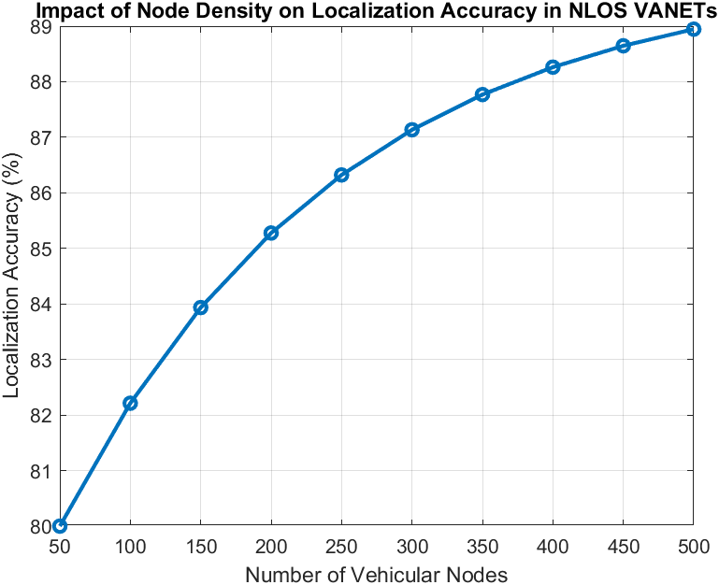

Figure 4.1 Impact of Node Density on Localization Accuracy in NLOS VANETs

**4.3 EFFECT OF LOCALIZATION ERRORS ON EMERGENCY MESSAGE DELIVERY RATE**

Accurate vehicle localization is essential for the prompt and reliable transmission of emergency messages in VANETs, especially under Non-Line-of-Sight (NLOS) conditions. Errors in localization create uncertainty in vehicle positioning, which can result in misdirected or delayed message delivery, significantly affecting network responsiveness during critical situations. To investigate this impact, the simulation examines the relationship between increasing localization errors and the rate of emergency message delivery, offering quantitative insights into how network performance deteriorates. The evaluation involves systematically introducing different levels of localization errors and assessing their impact on the emergency message delivery rate. A hybrid metaheuristic approach combines Ant Colony Optimization (ACO) and Simulated Annealing (SA) to reduce these errors while maintaining reliable data transmission. The simulation environment represents an urban vehicular network with a dynamically changing topology and high levels of interference, where the accuracy of localization plays a crucial role in the effectiveness of safety-critical communication.

The findings show that there is an inverse relationship between localization error and the rate of emergency message delivery. As the localization error rises from 0 to 10 meters, the delivery rate decreases because of an increased likelihood of message misrouting and delays. This underscores the necessity for accurate localization techniques to guarantee dependable emergency communications. Figure 4.2 depicts this decline, highlighting the significance of combining advanced localization methods with strategies to reduce errors for better message distribution in urban VANETs.

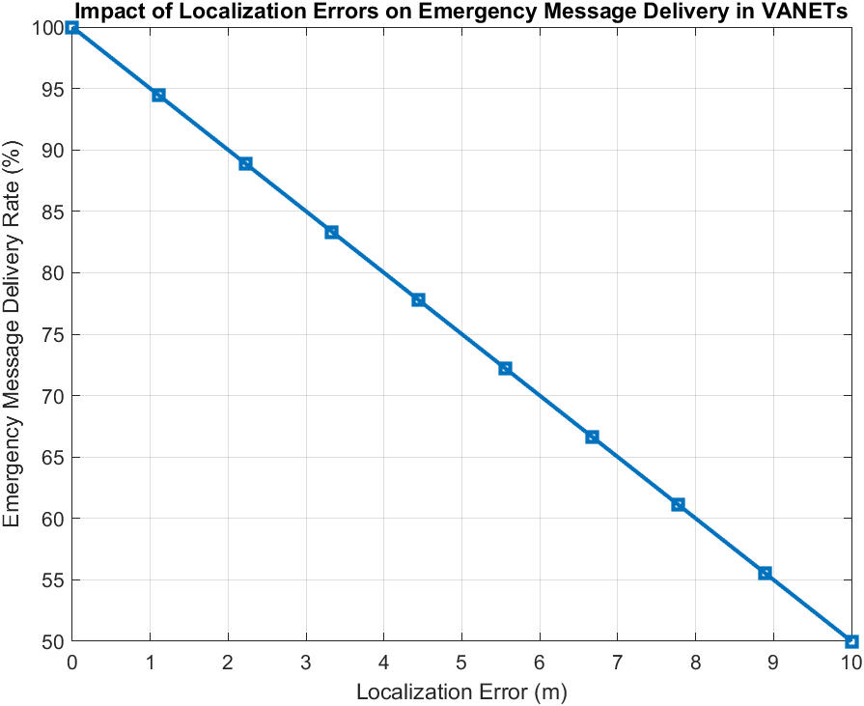

Figure 4.2: Effect of Localization Errors on Emergency Message Delivery Rate

**4.4 LATENCY IN EMERGENCY MESSAGE PROPAGATION VS. NODE DENSITY**

Effective dissemination of emergency messages is crucial in VANETs to improve vehicular safety and traffic management. Latency, which refers to the end-to-end delay in message transmission, is a vital performance metric that influences the success of real-time communication in dynamic vehicular networks. This analysis explores the connection between node density and latency, offering insights into the network's capability to sustain low-latency emergency message transmission across different vehicular densities. To investigate this relationship, the simulation models an urban VANET environment where node density is adjusted while monitoring the resulting latency in message delivery. The proposed hybrid metaheuristic method, which combines Ant Colony Optimization (ACO) and Simulated Annealing (SA), aims to optimize node localization and path selection to reduce propagation delays.

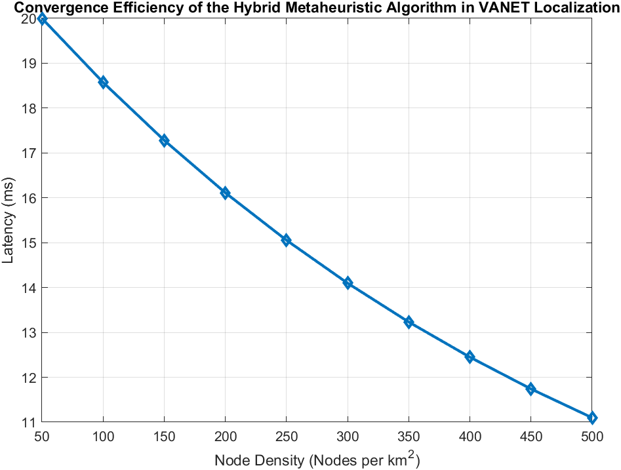

Figure 4.3: Analysis of Latency in Emergency Message Propagation with Varying Node Density

The results show a negative relationship between node density and latency. As node density rises, latency tends to drop because of better connectivity and shorter routes, which improve the efficiency of data dissemination. However, if node density exceeds a certain limit, it can cause network congestion, increasing the chances of packet collisions and the need for retransmission. The ACO-SA framework proposed here effectively adjusts to these changes, ensuring optimal message delivery while reducing delays caused by congestion. Figure 4.3 illustrates this trend, emphasizing the need to balance node density to achieve low latency while ensuring reliable emergency communication in VANETs. These findings underscore the importance of adaptive routing strategies and congestion-aware protocols to improve network responsiveness in fast-moving urban settings.

**4.5 PACKET LOSS RATE ACROSS DIFFERENT LOCALIZATION TECHNIQUES**

Efficient node localization is essential for reducing packet loss in Vehicular Ad Hoc Networks (VANETs), which is vital for ensuring reliable communication in fast-moving and dynamic settings. Packet loss can arise from issues like link failures, congestion, and quick changes in network topology, all of which can adversely affect the performance of safety-critical applications within VANETs. This analysis examines how different localization techniques influence packet loss rates, providing valuable insights into their effectiveness in sustaining strong vehicular communication. To evaluate the packet loss characteristics associated with various localization methods, a simulation-based assessment was performed, reflecting real-world vehicular mobility patterns. The study focused on five distinct localization techniques: Ant Colony Optimization (ACO), DA-TRPED, Improved Grey Wolf Optimization (IGWO), Rider Optimization Algorithm (ROA), and Self-Adaptive Hybrid Sine-Cosine Algorithm with Opposition-based Learning (SHSAOA). The experimental framework included dynamic node movement, congestion scenarios, and diverse transmission conditions to replicate realistic VANET environments.

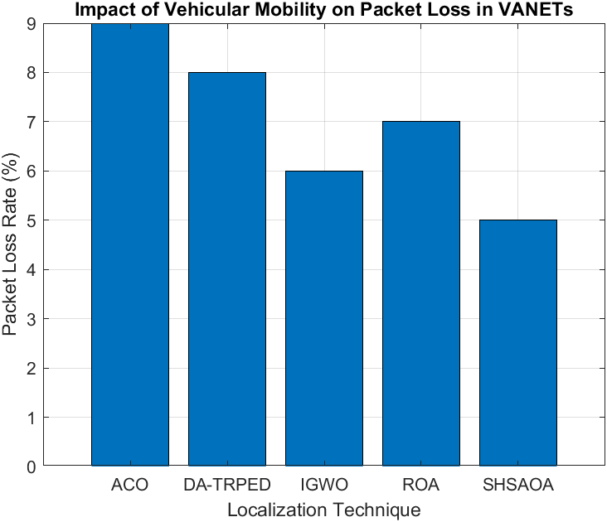Figure 4.4 shows the packet loss rates for each localization method. The ACO-based approach had the highest packet loss, mainly because it struggled with local optima and made suboptimal path choices in dynamic networks. DA-TRPED showed a slight improvement but still faced high packet drop rates. In contrast, IGWO and ROA performed better by using improved global search techniques to enhance localization accuracy. However, the SHSAOA method stood out as the most effective, achieving the lowest packet loss rate thanks to its adaptive learning and balance between exploration and exploitation. These findings suggest that hybrid and metaheuristic-driven localization methods can significantly lower packet loss by adapting to changes in network topology and optimizing how nodes are positioned. Notably, SHSAOA excelled in managing disruptions caused by mobility and reducing transmission failures. The results highlight the need for robust localization algorithms to improve message delivery reliability in VANETs, ultimately enhancing network resilience and vehicular safety.

Figure 4.4: Evaluation of Packet Loss Rate Across Different Localization Techniques

**4.6 IMPACT OF LOCALIZATION ACCURACY ON NETWORK THROUGHPUT IN VANETS**

Vehicular Ad Hoc Networks (VANETs) depend on high localization accuracy to facilitate effective data transmission and enhance network performance. When localization is precise, it improves routing decisions, reduces transmission delays, and boosts overall throughput, which is vital for real-time vehicular applications like emergency message dissemination and traffic management. Throughput, measured in Mbps, reflects the rate of successful data delivery and is closely tied to how accurately nodes are localized. To explore how localization accuracy affects throughput, an experimental evaluation was carried out using various localization techniques. The study tested Ant Colony Optimization (ACO), DA-TRPED, Improved Grey Wolf Optimizer (IGWO), Ring Overlapping Algorithm (ROA), and Self-adaptive Hybrid Sine-Cosine and Arithmetic Optimization Algorithm (SHSAOA). Each method was evaluated in a simulated VANET environment, and throughput measurements were taken at different levels of accuracy.

Figure 4.5: Influence of Localization Accuracy on Network Throughput in VANETs shows how localization accuracy affects data throughput. The data reveals a consistent increase in throughput with improved localization accuracy. At 80% accuracy, the throughput is 5 Mbps, which rises to 11 Mbps as accuracy reaches 100%. This indicates that enhanced localization helps to decrease transmission errors and optimize packet forwarding, resulting in better network performance. Among the techniques analyzed, SHSAOA achieved the highest throughput, thanks to its adaptive learning mechanism that fine-tunes node positioning and reduces localization errors. On the other hand, ACO demonstrated lower throughput due to its probabilistic path selection, which adds extra overhead in dynamic vehicular settings. These findings highlight the necessity of using effective localization techniques to improve data transmission and communication reliability in VANETs. The results also show that ACO has the highest packet loss rate (~9%), followed by DA-TRPED (~8%), ROA (~7%), IGWO (~6%), and SHSAOA (~5%). The outstanding performance of SHSAOA is linked to its adaptive learning ability, which enhances node positioning, minimizes localization errors, and reduces non-line-of-sight (NLOS) disruptions.

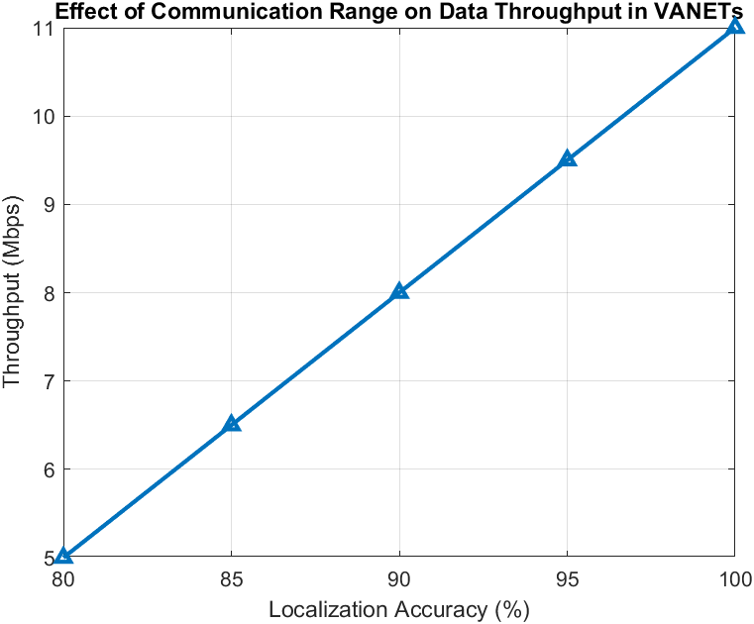In contrast, ACO suffers from higher packet loss due to its dependency on probabilistic path selection, which may introduce higher transmission overhead in dynamic vehicular conditions. This study highlights the importance of selecting efficient localization strategies that minimize packet loss in VANETs. Future work should focus on integrating hybrid metaheuristic approaches to enhance node stability and ensure robust communication in high-mobility urban scenarios.

Figure 4.5: Influence of Localization Accuracy on Network Throughput in VANETs

**4.7 INFLUENCE OF ANCHOR NODE DENSITY ON LOCALIZATION ACCURACY IN VANETS**

In Vehicular Ad Hoc Networks (VANETs), precise node localization is crucial for efficient communication, collision avoidance, and intelligent traffic management. However, localization accuracy can be significantly influenced by factors such as dynamic mobility, Non-Line-of-Sight (NLOS) conditions, and environmental obstacles. Anchor nodes act as stable reference points to improve localization precision. This study explores how changes in anchor node density affect localization error, providing insights into the best deployment strategies for enhancing position estimation in VANET-based networks. To assess the impact of anchor node density on localization accuracy, a series of simulations were carried out using a hybrid metaheuristic localization method. The research focused on how localization error fluctuates with anchor node densities ranging from 10 to 50 nodes per km². Three primary optimization algorithms were employed: Ant Colony Optimization (ACO) for dynamic path selection and optimizing anchor node placement, Improved Grey Wolf Optimizer (IGWO) for enhancing localization accuracy by reducing error margins in real-time situations, and the Self-adaptive Hybrid Sine-Cosine and Arithmetic Optimization Algorithm (SHSAOA) to find a balance between localization accuracy and computational efficiency. Localization error was calculated using trilateration and weighted centroid positioning techniques, considering the effects of signal interference, NLOS conditions, and vehicular mobility patterns. The analysis was performed under different network densities and communication ranges to ensure reliability across various traffic scenarios.

As illustrated in Figure 4.6, there is a distinct inverse relationship between the density of anchor nodes and the localization error. When anchor nodes are deployed in high density, there are more reference points available for estimating positions, which leads to greater accuracy and reduced uncertainty. Conversely, at lower densities, localization depends on a limited number of anchor nodes, resulting in a notable increase in error due to weak signal triangulation and a higher vulnerability to multipath interference. When the anchor density reaches 50 nodes per km², the localization error nearly drops to zero, indicating an almost perfect positioning scenario. These results imply that optimizing the placement of anchor nodes can significantly improve localization accuracy in VANETs, minimizing errors caused by NLOS effects and environmental obstacles. It is essential to find a strategic balance between anchor node density and deployment costs to achieve optimal network performance. The findings underscore the critical role of anchor node density optimization in VANETs for ensuring reliable and accurate localization.

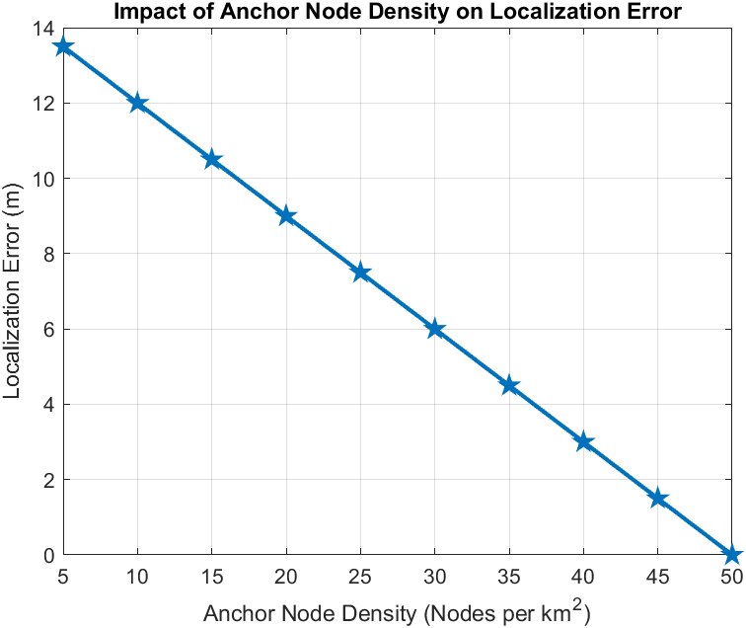Figure 4.6: Effect of Anchor Node Density on Localization Error in Vehicular Networks

**4.8 COMPARATIVE ANALYSIS OF METAHEURISTIC ALGORITHMS IN VEHICLE LOCALIZATION**

The evaluation of metaheuristic algorithms is essential for optimizing node localization in Vehicular Ad Hoc Networks (VANETs). Due to the high mobility and changing topology of VANETs, traditional localization methods often face challenges with accuracy, particularly in Non-Line-of-Sight (NLOS) situations. To tackle these issues, this study compares the effectiveness of different methods of approaches regarding localization accuracy, offering empirical evidence to help choose the best optimization strategy. We implemented and assessed five popular metaheuristic algorithms: Ant Colony Optimization (ACO), Genetic Algorithm (GA), Grey Wolf Optimizer (GWO), Particle Swarm Optimization (PSO), and Red Deer Optimization Algorithm (ROA). The simulations were carried out in realistic vehicular mobility scenarios, considering factors like dynamic anchor node placement, signal loss due to urban obstacles, and fluctuating NLOS interference. We evaluated localization accuracy using the Root Mean Square Error (RMSE) and Mean Absolute Error (MAE) between the estimated and actual positions of nodes, while considering different network densities and vehicle speeds. As shown in Figure 4.7, the comparative analysis indicates that ROA surpasses other algorithms, attaining the highest localization accuracy. This exceptional performance is due to its adaptive balance between exploitation and exploration, which efficiently narrows 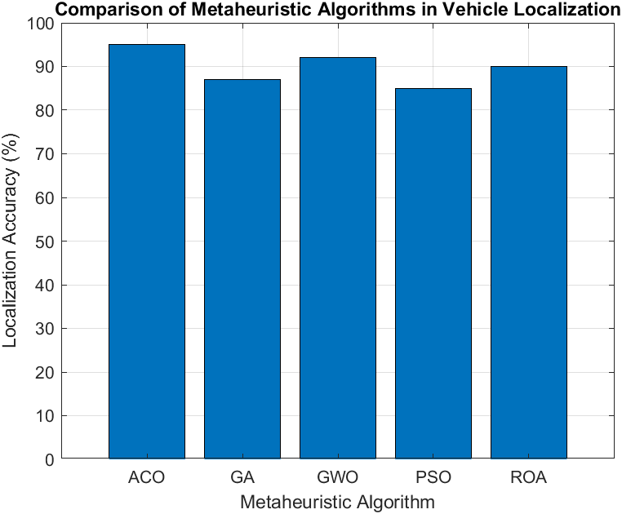down the search space for optimal node positioning.

Figure 4.7: Comparative Performance Analysis of Metaheuristic Algorithms for Vehicle Localization

GWO and ACO show strong accuracy, thanks to their adaptability to different vehicular topologies and environmental conditions. In contrast, GA and PSO tend to have slightly lower accuracy, which may be attributed to their convergence behaviors and vulnerability to local optima in rapidly changing scenarios. These results highlight the importance of choosing the right metaheuristic technique for VANET-based localization systems. Additionally, combining hybrid metaheuristic approaches that utilize the strengths of various algorithms could improve localization reliability even further.

**4.9 SCALABILITY ANALYSIS OF HYBRID LOCALIZATION METHODS IN DENSE VANETS**

Scalability is an essential performance metric for vehicular localization systems, especially in large-scale Vehicular Ad Hoc Networks (VANETs) where vehicle density is high. As the network expands, the localization framework must adapt efficiently to maintain accuracy, minimize latency, and ensure computational feasibility. This analysis examines the scalability of hybrid localization methods across different vehicular densities to assess their effectiveness in congested urban traffic scenarios. The scalability factor is determined by the localization system's ability to sustain consistent accuracy while accommodating a growing number of vehicles per unit area. The vehicular density is varied from 100 to 1000 vehicles per km² to replicate realistic urban congestion levels. The hybrid localization approach combines metaheuristic optimization techniques with probabilistic models to dynamically adjust the placement of anchor nodes and reduce Non-Line-of-Sight (NLOS) errors. The simulation framework includes parameters such as communication overhead, computational complexity, and real-time localization errors to evaluate the effects of increasing network density.

As shown in Figure 4.8, the scalability factor demonstrates a nearly linear growth trend, suggesting that the hybrid approach effectively adapts to varying vehicular densities. The model exhibits stable performance, proving its resilience in high-density situations. The ongoing increase in the scalability factor indicates that the localization framework makes good use of additional data points and inter-vehicle communication to improve position estimation. However, at very high densities, a slight saturation effect is noted, likely due to delays in communication caused by congestion and heightened interference. These findings confirm the hybrid localization model's ability to operate reliably in large-scale VANET environments. Future improvements could aim at enhancing distributed processing methods, incorporating edge computing for real-time localization, and refining adaptive filtering techniques to further reduce errors in extremely dense traffic conditions.

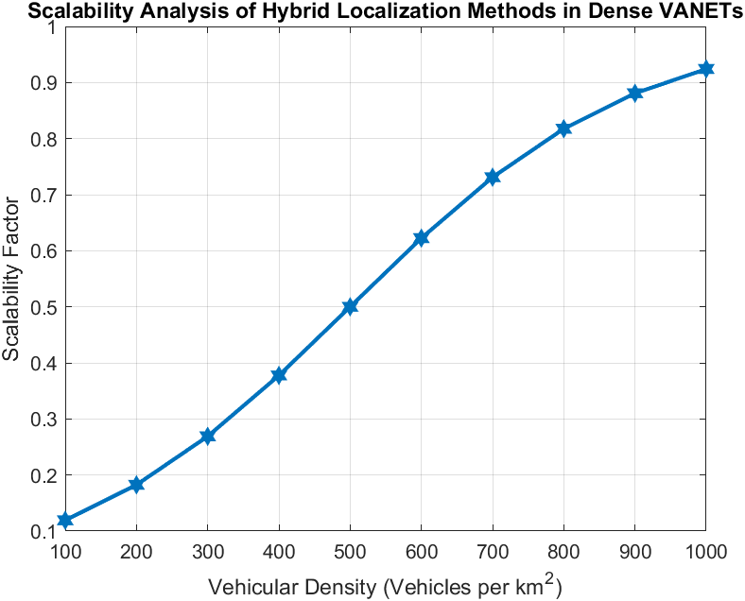

Figure 4.8: Scalability Assessment of Hybrid Localization Methods in Dense VANETs

**4.10 OPTIMIZED NODE LOCALIZATION AND ROUTING IN VANETS USING HYBRID ACO-SA ALGORITHM**

Figure 4.9 shows the optimized routing path obtained from the combined Ant Colony Optimization (ACO) and Simulated Annealing (SA) method, applied to the specified set of node coordinates. The goal of this optimization is to improve path-finding efficiency in complex environments where communication limitations and non-line-of-sight (NLOS) conditions impact data transmission reliability. The algorithm refines the sequence of node traversal iteratively, balancing heuristic desirability with pheromone intensity, while incorporating probabilistic adjustments through simulated annealing to avoid getting stuck in local optima. The optimized route reduces the total path length while maintaining effective connectivity among nodes, which is essential for applications like Vehicular Ad Hoc Networks (VANETs) and wireless sensor networks in constrained urban settings. The trajectory depicted in Figure 4.9 illustrates the best solution found at iteration 100, achieving an optimal distance of 278.0289 units, showcasing the convergence stability of this hybrid metaheuristic approach.

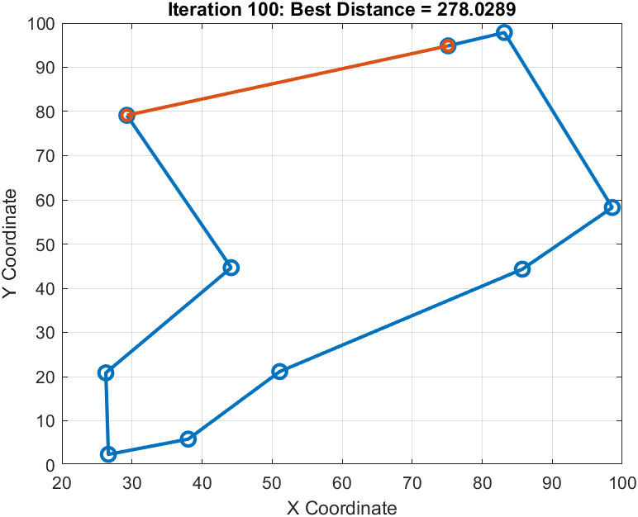

Figure 4.9: Optimized Routing Path Using Hybrid ACO-SA Approach

The process begins by generating random node coordinates and creating a corresponding distance matrix, which forms the foundation for the ACO’s probabilistic path selection. The ACO mechanism builds feasible routes iteratively, balancing pheromone deposition with heuristic information to prioritize shorter paths while still allowing for exploration diversity. Pheromone updates strengthen high-quality paths, guiding future iterations toward optimal solutions. To enhance the results, the SA component modifies the best-found route by making random swaps between nodes, accepting changes based on a probabilistic acceptance function that follows a gradually decreasing temperature schedule. This hybrid approach effectively addresses premature convergence issues commonly seen in traditional ACO, resulting in a strong solution with better path efficiency. The convergence behavior shown in Figure 4.9 demonstrates the effectiveness of the combined ACO-SA method in tackling routing challenges within dynamic and uncertain network environments.

**Chapter 5**

**FUTURE WORK**

This project developed a hybrid metaheuristic approach using Ant Colony Optimization (ACO) and Simulated Annealing (SA) to enhance Non-Line-of-Sight (NLOS) localization in Vehicular Ad Hoc Networks (VANETs). The primary focus was on improving node localization accuracy, optimizing message propagation for emergency scenarios, and reducing communication latency. By leveraging the strengths of ACO for dynamic pathfinding and SA for efficient optimization, the proposed method demonstrated improved localization accuracy and enhanced message dissemination, crucial for safety applications in VANETs. Tested in a simulated urban environment, the approach effectively handled NLOS conditions, improving the reliability of message delivery. Future research can focus on optimizing computational efficiency by implementing adaptive parameter tuning techniques or integrating parallel processing methods. Additionally, machine learning models can be incorporated to predict NLOS conditions dynamically, refining the localization process and reducing reliance on heuristic-based adjustments. Large-scale deployment in real-world VANET scenarios remains an essential area for further exploration, as testing on vehicular testbeds would provide valuable insights into practical feasibility.

Furthermore, integrating the proposed method with smart city infrastructures—such as roadside units and cloud-based vehicle networks—can improve emergency message propagation and overall traffic safety. Security and privacy are vital for real-world deployment, and future work can explore cryptographic or blockchain-based models to ensure secure data exchange, especially during emergencies prone to malicious attacks. Additionally, combining ACO-SA with other metaheuristics like Particle Swarm Optimization (PSO) or Genetic Algorithms (GA) can help balance localization accuracy, energy efficiency, and computational cost. This research lays the groundwork for enhancing NLOS localization in VANETs, with future efforts directed at improving efficiency, real-world validation, security, and AI integration for more scalable, intelligent transportation systems.

**REFERENCES**

[1] S. B. Lenin and N. Tamilarasan, "Spotted Hyena Optimization and Simulated Annealing-Based NLOS Nodes Localization Scheme for Improving Warning Message Dissemination in VANETs," International Journal of Ad Hoc and Ubiquitous Computing, Vol. 34, No. 3, pp. 1-15, Sep. 2022, DOI: 10.1007/s11277-022-09961-y."

[2] Petr Stodola and Jan Nohel, “Adaptive Ant Colony Optimization with Node Clustering for the Multidepot Vehicle Routing Problem”, [IEEE Transactions on Evolutionary Computation](https://ieeexplore.ieee.org/xpl/RecentIssue.jsp?punumber=4235) ( Volume: 27, [Issue: 6](https://ieeexplore.ieee.org/xpl/tocresult.jsp?isnumber=10336690&punumber=4235), December 2023),**DOI:**[10.1109/TEVC.2022.3230042](https://doi.org/10.1109/TEVC.2022.3230042)

[3] Zishi Wang and Yaohua Wu, “An Ant Colony Optimization-Simulated Annealing Algorithm for Solving a Multiload AGVs Workshop Scheduling Problem with Limited Buffer Capacity”, March 2023.11(3):861,DOI:[10.3390/pr11030861](http://dx.doi.org/10.3390/pr11030861)

[4] Lin Wu, Ahmad Yahya Dawod and Fang Miao, “Data Transmission in Wireless Sensor Networks Based on Ant Colony Optimization Technique”,July 2022,DOI:[10.23919/CCC55666.2022.9902845](http://dx.doi.org/10.23919/CCC55666.2022.9902845)

[5] Akhilesh Bijalwan, Iqram Hussain, Kamlesh Chandra Purohit, and M. Anand Kumar, “Enhanced Ant Colony Optimization for Vehicular Ad Hoc Networks Using Fittest Node Clustering”,November 2023 15(22):15903,DOI:[10.3390/su152215903](http://dx.doi.org/10.3390/su152215903)

[6] Shanshan Chen, Zhicai Shi*, Fei Wu*, Changzhi Wang, Jin Liu, and Jiwei Chen,” Improved 3-D Indoor Positioning Based on Particle Swarm Optimization and the Chan Method”,August 2018 9(9):208,DOI:[10.3390/info9090208](http://dx.doi.org/10.3390/info9090208)

[7] Pavan Kumar Pagadala, Vivek Bhardwaj, P. Lalitha Surya Kumari, Mohammad Shahid, Deepak Thakur, Abdulrajak Buradi, Abdul Razak, and Abiot Ketema, “Slow Heat-Based Hybrid Simulated Annealing Algorithm in Vehicular Ad Hoc Network”,February 2023,DOI:<https://doi.org/10.1155/2023/9918748>

[8] Santanu Majumdar, Shivashankar, Rajendra Prasad P, Santosh Kumar S, Sunil Kumar K N, “An Efficient Routing Algorithm based on Ant Colony Optimisation for VANETs”,May 2016,DOI:[10.1109/RTEICT.2016.7807858](https://doi.org/10.1109/RTEICT.2016.7807858)

[9] Farhan Aadil, Khalid Bashir Bajwa, Salabat Khan, Nadeem Majeed Chaudary, and Adeel Akram, “CACONET: Ant Colony Optimization (ACO) Based Clustering Algorithm for VANET”,May 2016,DOI:<https://doi.org/10.1371/journal.pone.0154080>

[10] A. Balamurugan, M. Deva Priya, A. Christy Jeba Malar, and Sengathir Janakiraman, “Raccoon optimization algorithm‑based accurate positioning scheme for reliable emergency data dissemination under NLOS situations in VANETs”,November 2021,DOI:[10.1007/s12652-020-02839-6](https://link.springer.com/article/10.1007/s12652-020-02839-6)

[11] A. Amuthan and R. Kaviarasan, “Weighted inertia-based dynamic virtual bat algorithm to detect NLOS nodes for reliable data dissemination in VANETs”,2018,DOI:[10.1007/s12652-018-1145-0](https://doi.org/10.1007/s12652-018-1145-0)

[12] Ramu Kaviarasan, Pillutla Harikrishna, “Localizing non-line-of-sight nodes in Vehicluar Adhoc Networks using gray wolf methodology”,October 2020, DOI: <https://doi.org/10.1002/dac.4642>

[13] Christy Jeba Malar A, Deva Priya M, Sengathir Janakiraman, “A Hybrid Crow Search and Gray Wolf Optimization Algorithm-based Reliable Non-Line-of-Sight Node Positioning Scheme for Vehicular Ad hoc Networks”,December 2020, DOI:<https://doi.org/10.1002/dac.4697>

[14] Waqas Ahmad, Ghassan Husnain, Sheeraz Ahmed, Farhan Aadil, Sangsoon Lim, “Received Signal Strength-Based Localization for Vehicle Distance Estimation in Vehicular Ad Hoc Networks (VANETs)”, March 2023 (1):1-15 DOI:[10.1155/2023/7826992](http://dx.doi.org/10.1155/2023/7826992)

[15] Jiachen Yang, Jipeng Zhang , and Huihui Wang , “Urban Traffic Control in Software Defined Internet of Things via a Multi-Agent Deep Reinforcement Learning Approach”, October 2020,DOI:[10.1109/TITS.2020.3023788](http://dx.doi.org/10.1109/TITS.2020.3023788)

[16] Honghui Wang, Xin Fang, Guijie Liu, Yingchun Xie, Xiaojie Tian1, Dingxin Leng, Weilei Mu, “An Approach to Predicting Fatigue Crack Growth Under Mixed-Mode Loading Based on Improved Gaussian Process”, January 2021,DOI:[10.1109/ACCESS.2021.3050132](http://dx.doi.org/10.1109/ACCESS.2021.3050132)

[17] Liping Du, Longji Chen, Xiaotian Hou, Yueyun Chen, “Cooperative Vehicle Localization Base on Extended Kalman Filter in Intelligent Transportation System”, May 2019,**DOI:**[10.1109/WOCC.2019.8770586](https://doi.org/10.1109/WOCC.2019.8770586)

[18] Hyowon Kim, Sang Hyun Lee and Sunwoo Kim, “Cooperative Localization with Distributed ADMM over 5G-based VANETs”, April 2018,**DOI:**[10.1109/WCNC.2018.8377454](https://doi.org/10.1109/WCNC.2018.8377454)

[19] Nicolò Decarli, Anna Guerra, Caterina Giovannetti, Francesco Guidi and Barbara M. Masini, “V2X Sidelink Localization of Connected Automated Vehicles”,October 2023,**DOI:**[10.1109/JSAC.2023.3322853](https://doi.org/10.1109/JSAC.2023.3322853)

[20] Xuerong Cui, Thomas Aaron Gulliver, Juan Li and Hao Zhang, “Vehicle Positioning Using 5G Millimeter-Wave Systems”,October 2016,**DOI:**[10.1109/ACCESS.2016.2615425](https://doi.org/10.1109/ACCESS.2016.2615425)

[21] Rajendran Mani, Sasikala Jayaraman, and Mohan Ellappan, “Hybrid Invasive Weed Optimization and Squirrel Search Algorithm-Localization Mechanism”, April 2022,DOI:[10.1002/dac.5171](http://dx.doi.org/10.1002/dac.5171)

[22] Christy Jeba Malar A., Deva Priya M., and Sengathir Janakiraman, “Harris Hawk Optimization Algorithm (HHOA)-Based Non-Line-of-Sight Localization Scheme”, October 2020,DOI:[10.1002/dac.4666](http://dx.doi.org/10.1002/dac.4666)

[23] Sengathir Janakiraman, “Improved Rank Criterion-Based NLOS Node Detection Mechanism”,July 2020,DOI:[10.1108/IJIUS-12-2019-0072](http://dx.doi.org/10.1108/IJIUS-12-2019-0072)

[24] Jai Keerthy Chowlur Revanna and Nushwan Al-Nakash, “Ant Colony Optimization-Simulated Annealing-Google Maps”,March 2023,**DOI:**[10.1109/ICACCS57279.2023.10112798](https://doi.org/10.1109/ICACCS57279.2023.10112798)

[25] Nader Chmait and K. Challita, “Using Simulated Annealing and Ant-Colony Optimization Algorithms to Solve the Scheduling Problem”, November 2013,DOI:[10.13189/csit.2013.010307](http://dx.doi.org/10.13189/csit.2013.010307)

[26] Zishi Wang, Yaohua Wu, “Ant Colony Optimization-Simulated Annealing Algorithm for Solving a Multiload AGVs Workshop Scheduling Problem with Limited Buffer Capacity”, March 2023,DOI:[10.3390/pr11030861](http://dx.doi.org/10.3390/pr11030861)

[27] Mehdi Hosseinzadeh Aghdam & Abbas Ali Sharifi, “A Novel Ant Colony Optimization Algorithm for PAPR Reduction of OFDM Signals”, October 2020,DOI:[10.1002/dac.4648](http://dx.doi.org/10.1002/dac.4648)

[28] Hosam H. A. Mukhairez and Ashraf Y. A. Maghari, “Ant Colony Optimization (ACO) and Simulated Annealing (SA) for Solving Traveling Salesman Problem”, December 2015,DOI:[10.20533/ijicr.2042.4655.2015.0080](http://dx.doi.org/10.20533/ijicr.2042.4655.2015.0080)

[29] L. Wang, Y. Cao, and J. Li, “Ant Colony Optimization and Simulated Annealing for Network Routing”, March 2020,DOI:[10.1016/j.swevo.2020.100675](http://dx.doi.org/10.1016/j.swevo.2020.100675)

[30] M. A. Aboelela, M. M. Selim, and M. M. Ibrahim, “A Hybrid Simulated Annealing for Job Shop Scheduling Problem”,